Tramroads in East Shropshire

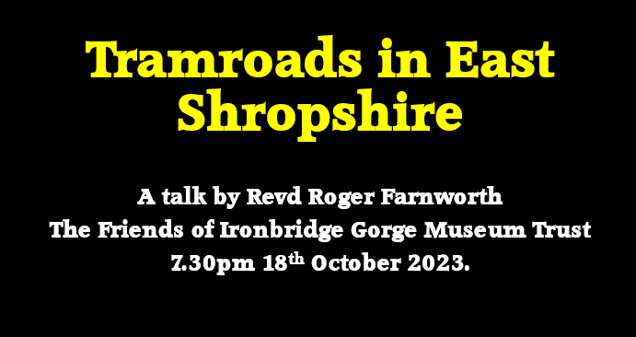
Slide 1 – A Short Personal Introduction
- For just under 17 years I was a Civil Engineer working in Local Government – GMC, Manchester City Council and Stockport MBC. Highways and Structures.
- A Career change in the late-1990s saw me becoming a parish priest. I retired from the role of Rector of Ashton-under-Lyne in Greater Manchester at the end of 2021. I live in Malinslee in Telford, my wife continues to work for the Church of England.
- I have a BSc in Civil Engineering and an MA in Mission and Ministry.
I tell you this to indicate that while I only claim to be an enthusiastic amateur as far as the Tramroads in this area are concerned, I can claim at least a little bit of engineering understanding. But, also to make it clear that I can in no way be considered a native of the area having moved here at the end of 2021. So, I am sure that most of you will have a much better knowledge of East Shropshire than I do!

Slide 2 – I write blog about railways and tramroads which means that, if you so desire, you can find the notes for this talk online. As an enthusiast, I have taken to walking many of the old railway and tramroad routes over the past 18 months and writing about them on my blog. The QR code should take you directly to the relevant page on the blog.

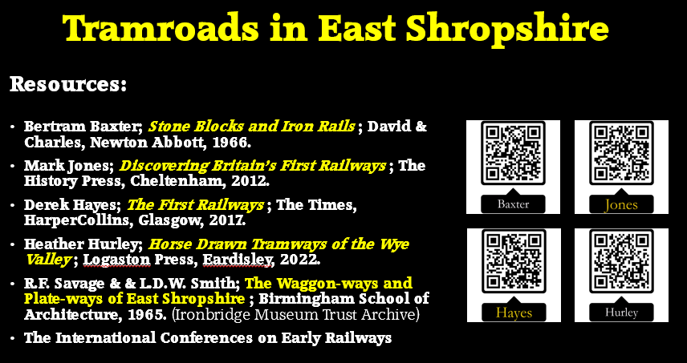
Slide 3 – Resources
Three of the first four books on this slide are relatively easy to obtain. The first is not. If you find one online it is likely to be expensive!
Savage and Smith’s Research is held in original form in the Ironbridge Museum Trust Archive.
The final reference is to a series of conferences which take place every 4 years which are organised jointly by the Institution of Civil Engineers; the National Railway Museum, York; the Newcomen Society; the Railway and Canal Historical Society; and the Stevenson Locomotive Society. The papers are generally erudite and informative but also highly detailed. Members of the Railway and Canal Historical Society also have access to a dedicated Early Railways Research Group.
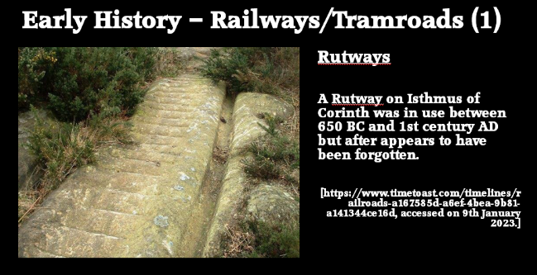
Slide 4 – Rutways

Runways (rock-cut grooves which served as guides for sledges or wheeled carts) were one of the earliest forms of railway, with examples known internationally from the Classical period. The categorisation of several of these examples as railways, rather than furrows formed by repeated usage or wheel guides on difficult sections of roads, has sometimes been controversial.
A rutway on Isthmus of Corinth was in use between 650 BC and 1st century AD but after that appears to have fallen into disuse. [21]
At least one Roman mine on the Continent was known to use a railway in the form of stone-cut ruts. Localised rutways from the Industrial Period are known in Britain. [22][25] Several Cornish Rutways might date back to the 1550s and be associated with Burchard Cranich and Ulrich Frosse. [25]
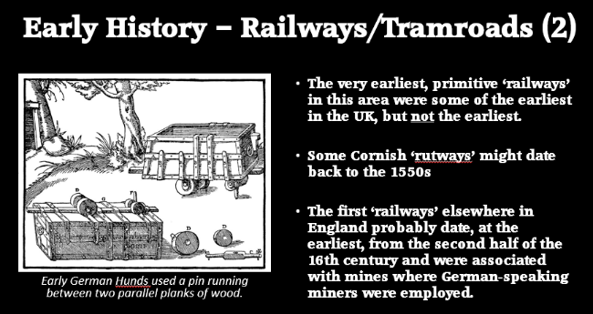
Slide 5 - Wooden Waggonways (1)

The very earliest primitive ‘railways’ in East Shropshire were some of the earliest in the UK, but not the earliest. … We have just noted the Cornish Rutways of 16th Century.
The first ‘railways’ elsewhere in England probably date, at the earliest, from the second half of the 16th century and were associated with mines where German-speaking miners were employed. These would have been Wooden Waggonways. Beyond reasonable doubt, we know that they were in use in Cumbria as early as 1569. And soon after at Talybont near Aberystwyth. [1: p20][23]
The drawing on the slide shows a Leitnagel Hund and comes from a medieval text by Georgius Agricola, De Re Metallica, 1556. [24] Note the guide pin which kept the hunds on ‘rails’ which were no more than planks of wood. The system “had some characteristics of a railway, but differs from them in that neither wheels nor rails were flanged.” [1: p21]
Peter King tells us that some very primitive systems were in use in Europe over the centuries but “the earliest railway-like transport system … was the Leitnagel Hund. … Planks were laid along the mine passage with a gap between them, and the truck – hund (German for dog or hound) or truhe (box or chest) – had a guide pin that pointed down between the planks to keep the truck going in the right direction. The word hund could be derived from the Magyar hintó, meaning a carriage. If so, this points to an origin in the mines of Hungary, which at the time included Slovakia and Transylvania. The system was widely used in central Europe in the early sixteenth century, and may go back to the fifteenth or even the fourteenth century.” [1: p20][23]
The German/Austrian/Hungarian system was introduced in the UK in Cumbria to ‘Company of Mines Royal’ sites at Caldbeck, Newlands, and Grasmere and also at that company’s mines at Talybont near Aberystwyth. King notes that “Documentary evidence indicates they used ‘small rowle wagons bound with iron’ in copper mines at Caldbeck …The first of these … near … Silver Gill at Caldbeck, where investigation has yielded the remains of some plank rails and possible sleepers.” [1: p20][23]
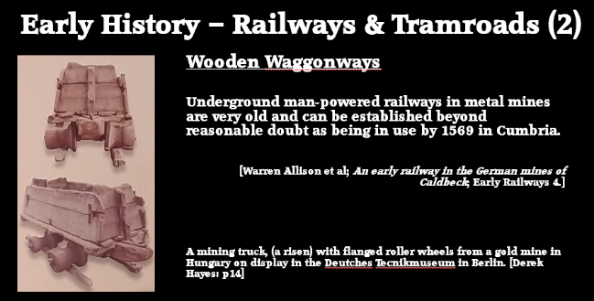
Slide 6 – Wooden Waggonways (2)
This next slide shows a development of the ‘hund’ which was in use in Hungary by the time the first UK ‘hunds’ appeared. Note the flanged wheels formed from tree trunks and rails which were poles rather than planks. [24: p14]
It is this development which ultimately brings us back to Shropshire!
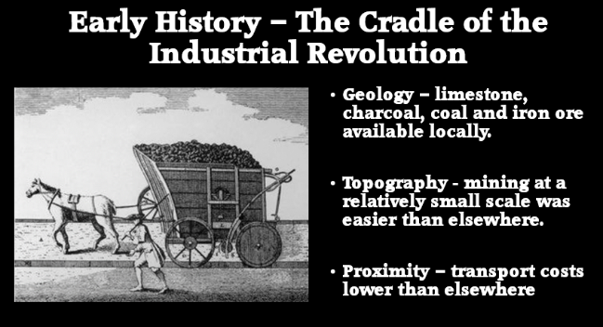
Slide 7 – It is here that major steps forward occurred in the production of cast and wrought iron.
The geology of the immediate area was a crucial factor in these developments. Limestone, coal bearing strata and iron ore were all easily available in the one, relatively small area. Initially the iron production processes needed charcoal, also readily available in the wooded areas which surrounded the Severn Gorge.
Because of the topography, mining at a relatively small scale was easier than elsewhere as mining could be done by ‘inset’ (horizontal galleries) rather than pits. The proximity of necessary materials meant that transport costs were lower than elsewhere.
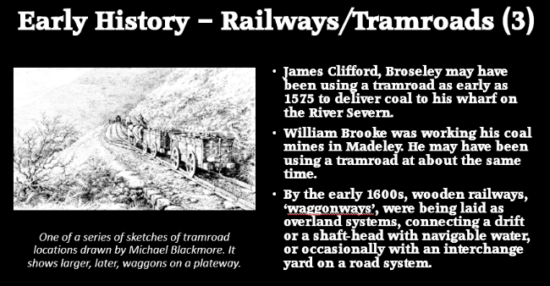
Slide 8 – It is likely that the first real railway can be dated to sometime in the late 16th century. Wherever the three factors just mentioned came together then short railways were likely to develop to feed industrial processes. Apart from a possible line at Barnard’s Castle (1555), probably the first railway had wooden rails and was either built by James Clifford near Broseley or William Brooke near Madeley, perhaps as early as the 1570s.
Certainly by “the opening years of the 17th century … wooden railways, ‘waggonways’, were being laid as overland systems, connecting a drift or a shaft-head with navigable water, or occasionally with an interchange yard on a road system.” [5: p22]
Whatever the date, it seems that before James Clifford died in June 1613 he had created a local system of transportation to take coal from the coalface to the consumer via wooden waggonways in such quantities as to turn a small domestic market into an export orientated one using the River Severn. [28] … If we take this latest date, then Clifford’s railway is trumped by one line at Wollaton in Nottinghamshire for which there is evidence of its use as early as 1604.
During the 17th century there were development in other areas of the UK: the Nottinghamshire Coalfield; then in the catchment of the River Tyne and the area around Newcastle-upon-Tyne; then in Whitehaven, Cumbia; and at Sheffield Park in Yorkshire.
In King’s opinion it is likely that the first real railway can be dated to sometime in the late 16th century. He identifies one ‘railway’ serving “the mines of James Clifford near Broseley in Shropshire, which has no clear date of construction. As Clifford was mining coal by 1575, the funicular railway, by which coal was let down from mines to trows (barges) operating on the River Severn, is likely to have preceded the others. Nevertheless, William Brooke was working his coal mines in Madeley, on the other side of the Ironbridge Gorge, where similar problems would have arisen, but that is only known because Arnold Bean of Worcester owed Brooke money when he died in 1579.” [1: p21]
Gwyn & Cossons concur with King. They say that “documentation dating from the opening years of the 17th century indicates that wooden railways, ‘waggonways’, were being laid as overland systems, connecting a drift or a shaft-head with navigable water, or occasionally with an interchange yard on a road system.” [5: p22]
Like King, they say that most of what we know of these waggonways “comes from legal disputes, and for this reason it is quite possible that there were other systems of which historians are unaware because they prompted no quarrels.” [5: p22]
They also cite James Clifford’s wagonway, although with a later date, which ran from a “colliery at Broseley near the Severn Gorge in Shropshire, on the south side of the river, to a wharf at the Calcutts, slightly downstream of the later Iron Bridge; it was laid in October 1605, was a mile or so long.” [5: p22]
King asserts that there were “a number of mines along the side of the [Severn] gorge in the succeeding period and each apparently had an associated railway. Some mines were pits, but some were ‘insets’ – mines operated through an audit, and in these cases the railway extended underground to the coalface.” [1: p22]
Whatever the date, it seems that before James Clifford died in June 1613 he had created a local system of transportation to take coal from the coalface to the consumer via wooden waggonways in such quantities as to turn a small domestic market into an export orientated one using the River Severn. [28]
King turns his attention away from the Severn Gorge and looks at subsequent developments in the Nottinghamshire Coalfield; then in the catchment of the River Tyne and the area around Newcastle; then in Whitehaven, Cumbia; and at Sheffield Park in Yorkshire. We need to retain our focus on the Severn Gorge and the area immediately to the North which eventually became Telford.
When King turns back to Shropshire. He says: “Shropshire railways … form a different tradition from Newcastle waggonways. The waggons were smaller because the mines were often insets (rather than pits). The railway often started at the coalface and a smaller waggon meant that only a narrow adit had to be made through dead ground. The descent to the river down the side of the Severn gorge was precipitous, and the descent was controlled using a self-acting inclined plane, something not used near Newcastle until the late eighteenth century, but probably in Shropshire for its first railway. Wilcox’s & Wells’ railway to Calcutts may have been down Birch Batch. Its terminus was later called Jackfield Rails, and it remained in use well into the nineteenth century.” [1: p25]
Gwyn & Cossons comments about the Shropshire coalfield mirror that of King. They say that the Shropshire coalfield “developed smaller capacity systems running on narrower gauges. Here, mines were mainly levels, rather than deep mines such as prevailed in the north-east, and so a compact waggonway could run from the coalface to daylight and then down to navigable water. The Severn Ironbridge Gorge and its immediate environs were home to many such railways. From the mid-18th century, similar waggonways also ran direct from ironstone mines to Bedlam furnaces downstream of the later Iron Bridge.” [5: p23]
King says that a “longer railway, ultimately from John Wilkinson’s New Willey Furnace of 1757, went down Tarbatch Dingle to Willey Wharf but was probably built in the 1700s to serve coalmines and remained in use in parts for some 300 years, though from 1862 it led to the Severn Valley Railway, rather than a river wharf. North of the Severn, the lords of Madeley had railways at Madeley Wood when they let their mines in 1692.” [1: p25] We will come across this tramroad below.
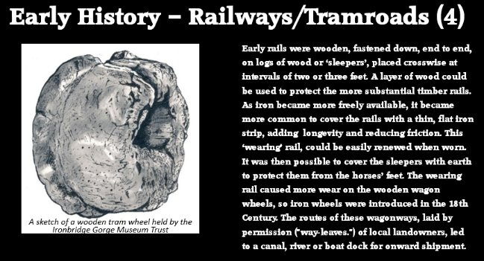
Slide 9 – Early rails were wooden, fastened down, end to end, on logs of wood or ‘sleepers’, placed crosswise at intervals of two or three feet. A layer of wood could be used to protect the more substantial timber rails.
As iron became more freely available, it became more common to cover the rails with a thin, flat iron strip, adding longevity and reducing friction. This ‘wearing’ rail, could be easily renewed when worn.
It was then possible to cover the sleepers with earth to protect them from the horses’ feet. The wearing rail caused more wear on the wooden wagon wheels, so iron wheels were introduced in the 18th Century. The routes of these wagonways, laid by permission ("way-leaves.") of local landowners, led to a canal, river or boat dock for onward shipment.
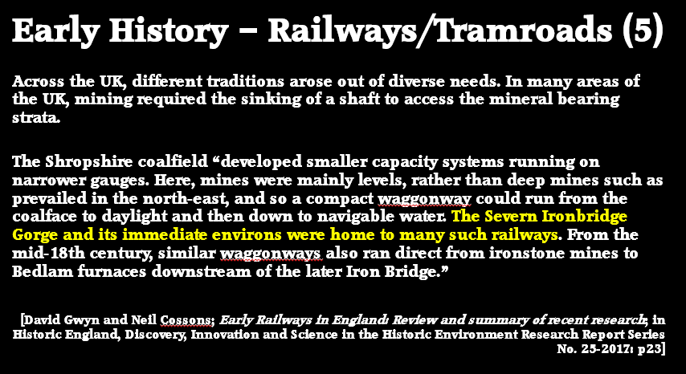
Slide 10 – Developments in Shropshire seem to have taken a different path to those elsewhere, particularly in the Northeast.
Across the UK, different traditions arose out of diverse needs. In many areas of the UK, mining required the sinking of a shaft to access the mineral bearing strata.
In Shropshire, at least at first, this was not the case. Waggons were generally smaller as access was usually through insets, railways started at the ‘coal-face’ and smaller waggons meant that only a narrow ‘adit’ needed to be made through dead ground.
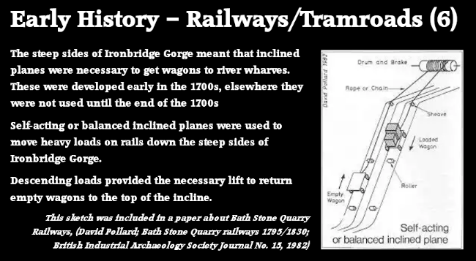
Slide 11 – The steep sides of Ironbridge Gorge meant that self-acting inclined planes were necessary to get wagons to river wharves. These were developed in Shropshire early in the 1700s, elsewhere they were not used until the end of the 1700s.
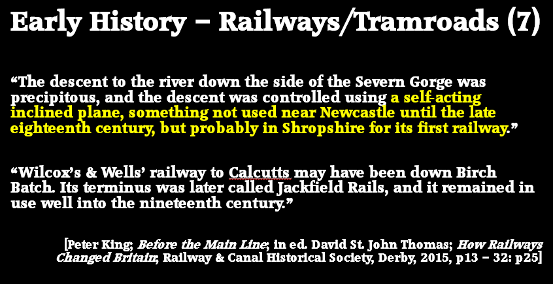
Slide 12 – One acknowledged authority on early tramroads, Peter King, says: “The descent to the river down the side of the Severn Gorge was precipitous, and the descent was controlled using a self-acting inclined plane, something not used near Newcastle until the late eighteenth century, but probably in Shropshire for its first railway.”
He notes that one early example was: “Wilcox’s & Wells’ railway to Calcutts may have been down Birch Batch. Its terminus was later called Jackfield Rails, and it remained in use well into the nineteenth century.” [1: p25]
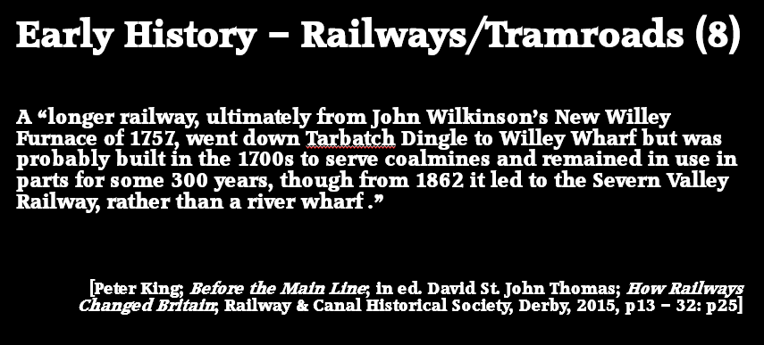
Slide 13 – King also highlights a “longer railway ultimately from John Wilkinson’s New Willey Furnace of 1757, went down Tarbatch Dingle to Willey Wharf but was probably built in the 1700s to serve coalmines and remained in use in parts for some 300 years, though from 1862 it led to the Severn Valley Railway, rather than a river wharf.” [1: p25]
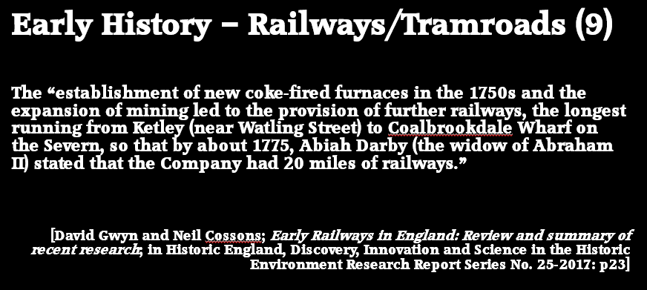
Slide 14 – Gwyn & Cossons say that the “establishment of new coke-fired furnaces in the 1750s and the expansion of mining led to the provision of further railways, the longest running from Ketley (near Watling Street) to Coalbrookdale Wharf on the Severn, so that by about 1775, Abiah Darby (the widow of Abraham II) stated that the Company had 20 miles of railways.” [5: p23] [cf: 1: p25]
King notes that “Other railways ran to land-sale wharfs on Watling Street. In all, five gauges of railway were in use in the area, with those wholly above ground probably of a similar size to those at Newcastle.” [1: p25]
Gwyn & Cossons found that railways deriving from Shropshire practice “were to be found in coalfields which were adjacent and technically influenced by it. Staffordshire and Warwickshire, as well as parts of Wales and of Scotland.” [5: p23]
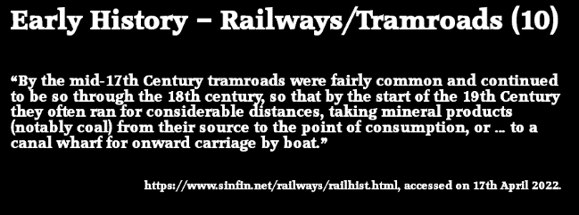
Slide 15 – “By the mid-17th Century tramroads were fairly common and continued to be so through the 18th century, so that by the start of the 19th Century they often ran for considerable distances, taking mineral products (notably coal) from their source to the point of consumption, or … to a canal wharf for onward carriage by boat.”
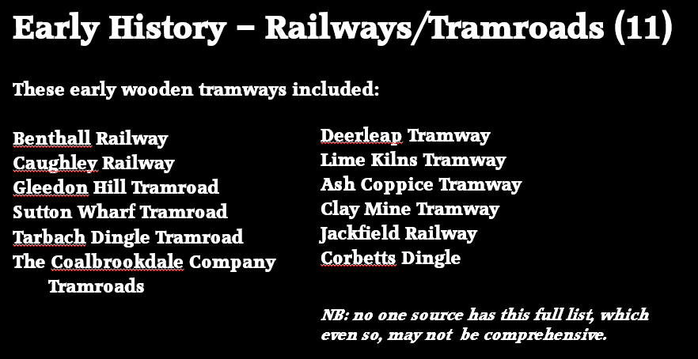
Slide 16 – Early wooden tramroads in and around the Severn Gorge and in East Shropshire as a whole are noted in works of Bertram Baxter, [4] Savage & Smith, [6] Catherine Clark & Judith Alfrey. [13] The list is not exhaustive but includes, at least:

- Benthall Railway [7][13]
- Caughley Railway [8]
- Gleedon Hill Tramroad [9]
- Sutton Wharf Tramroad [10]
- Tarbach Dingle Tramroad [11]
- The Coalbrookdale Company Tramroads [12]
- Deerleap Tramway [13]
- Lime Kilns Tramway [13]
- Ash Coppice Tramway [13]
- Clay Mine Tramway [13]
- Jackfield Railway [6]
- Corbetts Dingle [6]

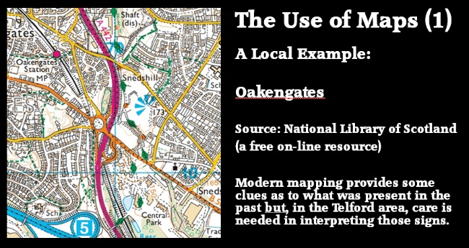
Slide 17 – In a while we will look at the use of cast-iron and wrought-iron, but first I want to explore the use of maps in identifying the locations of the different tramroads we have already encountered and then introduce the work done by Savage and Smith in the 1960s.

It takes relatively little effort to recover a great deal of information about the railways which existed from the latter part of the 19th century through to the present day. The National Library of Scotland holds an archive of Ordnance Survey Maps for the whole of the UK which can be accessed, free of charge, online. It is possible to follow the development of our modern railway system through looking at these maps. Here is a local example – the area Southeast of the centre of Oakengates: [16]

This is a modern map Ordnance Survey Map of Oakengates. The M54 can be seen bottom-left, the A442, Queensway snakes North-South across the extract; the old A5 (now B5061) runs diagonally from left to right; the remaining railway line runs top-left to middle-bottom.
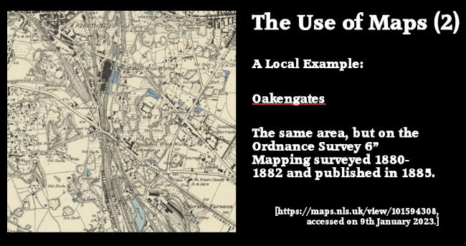
Slide 18 – This is an Ordnance Survey 6” Map of approximately the same area in 1880/82. The area is densely populated with railways, the majority of which have now disappeared. It is an early map but not early enough to define tramroad routes in the area. [14] Major features are:

- GWR Mainline from Shrewsbury to Wolverhampton
- LNWR Coalport Branch
- GWR ‘siding’ to Randlay and Grange Colliery
- The Lilleshall Company exchange sidings.
- Snedshill Ironworks and Brickworks
- Priorslee Furnaces
- Lilleshall Company Railways
- Shropshire Canal

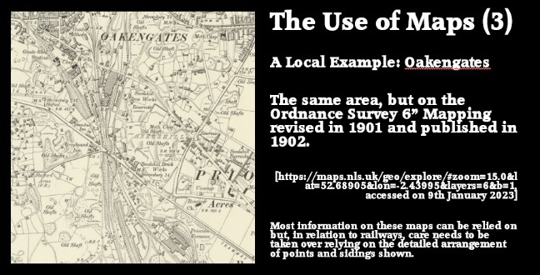
Slide 19 – The same area again, but on the 1901 6” OS Map. Better clarity but beginning to lose older details from 20 years previously. Both the 1882 survey and the 1902 survey are excellent for following the rail routes, not quite so reliable on detail such a point locations and numbers of sidings. Neither map gives enough detail to be able to be sure of disused tramroad routes. [15]
The GWR Birmingham & Shrewsbury Line enters the extracts in the Northwest and their Oakengates station can be made out in the top left – both Goods shed and passenger Station. It then passes in tunnel under the area South of the centre of Oakengates and leaves the extracts in cutting at around the bottom-centre of the maps. Entering at approximately the third point at the top of the extracts is the LNWR Wellington & Coalport Branch, known later as the LNWR Coalport Branch. Its Goods Sheds can be seen right at the top of each extract. Its passenger station was known as ‘Oakengates Market Street’ and was sited just North of the top edge of this map extract.
Also shown on both extracts is the Industrial or Mineral Railway which was part of the Lilleshall Empire. It enters the extracts at approximately the mid-point of the top edges. Both extracts also show a Tramroad (Tramway) entering from the bottom-right corner.
Priorslee Furnaces can be seen bottom-right. A little to the Northwest are Snedhill Brickworks. Further to the North are Snedshill Ironworks and the Nail Works, both close to the centre-top of the extracts. Old canals can also, relatively easily be picked out on the earlier extract. The most significant being the Coalport Branch of the Shropshire Canal (which on the first extract runs to the East of Snedshill Ironworks but which has disappeared at this location on the 1901 extract) and the Ketley Branch of the Shropshire Canal which appears only as earthworks on the left side of both extracts.
The detail is extraordinary, at least it is if you compare it to even earlier mapping!
When we start looking for earlier maps, the online resources are more limited and a visit to the local archives is advised. I have found quite a bit of earlier information here (at the Iron Bridge Gorge Museum Archives) and also at the Shropshire Archives in Shrewsbury.
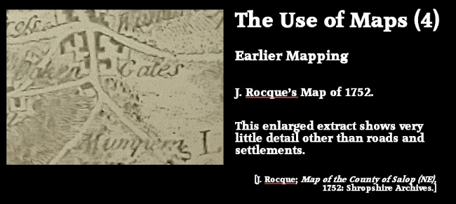
Slide 20 – What about earlier mapping? ….
J. Rocque’s Map of 1752 is held in the Shropshire Archives in Shrewsbury. It’s a little clearer than suggested by my out-of-focus photo but very sparse on detail. [17]

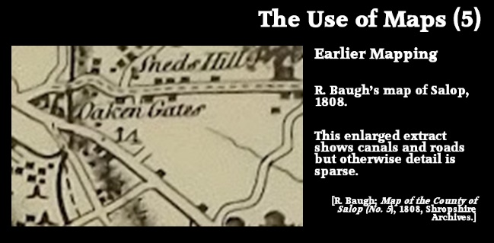
Slide 21 – about 50 years later. …
R. Baugh’s map of Salop, 1808. The black line is that of the Shropshire Canal and its Ketley Branch. Roads are more clearly shown but there is still no indication of tramroad routes. [18]

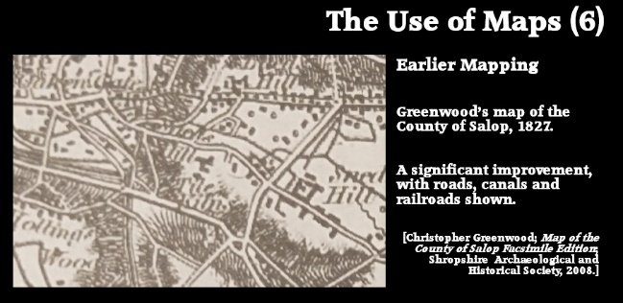
Slide 22 – another 20 years on. …
Greenwood’s map of the County of Salop of 1827 has a great deal more detail but can be confusing to read. … The Canal and Tramroads can be picked out along with major roads. [19]
Between 1817 and 1831 he produced 35 county maps at a scale of 1” to 1 mile. Shropshire was the 29th of the 35. A facsimile edition was produced by Shropshire Archaeological and Historical Society in 2008 and can be purchased at the Shropshire Archive in Shrewsbury.

On the extract from Greenwood’s map above (1827), Oakengates is in the top-left, and Snedshill on the right. Two lengths of Canal can be seen – the Shrewsbury Canal Coalport Branch runs North/South about one third in from the left of the image. The Ketley Branch runs approximately East/West at the centre-left of the image. No railways are shown. As they have yet to be built. I cannot identify the Tramroad (Tramway) which appears on the two 6” OS map extracts above. There are other lines drawn on the map which may well be either Tramways or lanes. The lines drawn in the bottom left of the extract are most likely tramways, as is the line drawn on the right of the image just above Snedshill Barracks. I have still to look at the other possibilities.
Greenwood’s mapping suggest that the local road network had developed significantly between 1808 (Baugh’s map) and 1827. Given the resources available to him Greenwood’s mapping is actual of high quality but, in style at least, looks back towards the mapping of the 18th century.
The Ordnance Survey was producing its earliest editions from 1811 onwards. The map for this immediate area is Map 61 (NE) and was produced at a scale of 1” to 1 mile. This next image is a photograph of the same area as in the other map extracts. I photographed it at Shropshire Archive. Unfortunately, the image is a little out of focus.
Oakengates is, again, in the top-left. The canals can be seen clearly as can two tramways, each of which is marked as a ‘Rail Road’ on the right of the image, close to Snedshill Barracks. The area has yet to be penetrated by model railways. What seems to be Snedshill Ironworks appears in the top half of the extract below, to the left-of-centre.
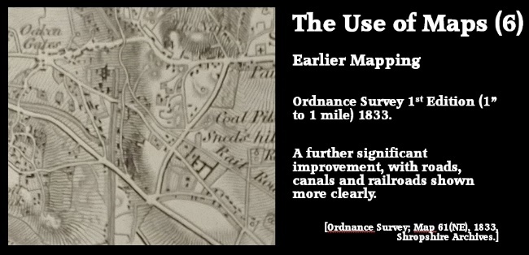
Slide 23 – the Ordnance Survey 1st Edition – 1” to a mile of 1833 – improved clarity with Rail Roads marked but still difficult to interpret. … The northern part of the Shropshire Canal has been abandoned but the Ketley branch and the length South of Oakengates is still in use. This still predates modern railways. [20]
These map extracts illustrate how difficult it is to be sure, from maps alone, what tramroads/tramways were in existence. Physical evidence is also nowhere near as good as for the later railways as much evidence has been destroyed by later building works, highways and railways.
Much does still remain in museums and can be discovered through careful study of maps and through site visits.
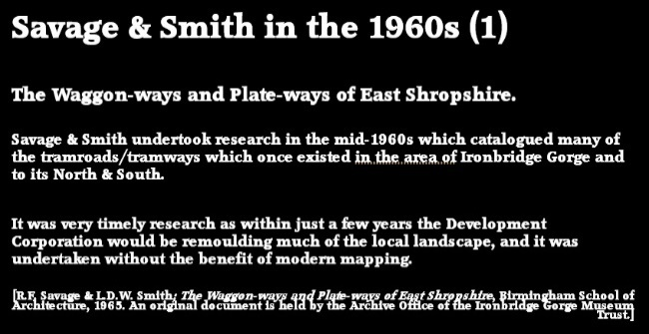
Slide 24 – So, we conclude from looking at these maps that great care is needed in interpreting what is shown. These maps can be supplemented by the various Council land maps and terriers and by maps drawn for other purposes – sale of land, plans for railway routes which either came to fruition or did not. Savage and Smith, in the 1960s, sought to codify what was available both on maps and on the ground.
It was very timely research, because within just a few years the Development Corporation would be remoulding much of the local landscape. They undertook their work without the benefit of modern mapping tools. All their maps are hand-drawn!
The Trust holds an original copy of a study undertaken by R.F. Savage and L.D.W. Smith in the 1960s (1965). The study’s title is The Waggon-ways and Plateways of East Shropshire. It identified and highlighted the routes of a number of tramways in the vicinity of the Gorge and over a much wider area. It was timely research as very soon the Development Corporation would be dramatically altering the landscape in and around Telford. It was research that was unable to rely on some of the methods available in the 21st century. Nonetheless it was a critically important piece of work. If this subject interests you, I am sure that the Archive will be happy for you to look at the original! [6]
The next slides provide details that Savage and Smith were able to establish with some certainty and the approximate periods in which each Tramroad operated. The periods used by Savage and Smith are shown on a series of tracings from the Ordnance Survey 1” to a mile series. These maps give a clear idea of the way in which these early tramroads were first introduced, proliferated extensively and then went into decline.
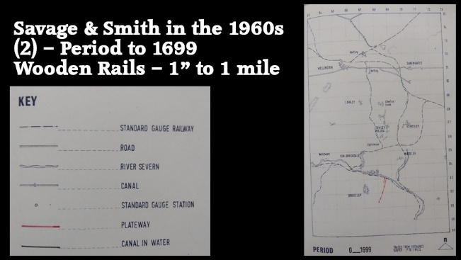
Slide 25 – First, they document the early wooden tramroads that we have already discussed. The first of three slides shows what was present in the period up to 1699. [6: p79] The key appears on each of the following slides, so I suggest that you focus of the right side of these slides.
Just two lines are shown. They are in the Broseley and Jackfield/Calcutts area. After some investigation, Savage and Smith concluded, in 1965, that James Clifford had let coal-mining rights on land to the South of the River Severn to Richard Wilcox for the mining of coal. Clifford himself retained the right to extract coal in the area immediately behind Calcutts Wharf. There may have been similar lines in the Madeley area which are not noted by Savage and Smith..
Apparently, Wilcox constructed an inclined plane up from the wharf and a tramroad which ran South to his mine which was about a mile away at Birch Meadow. Clifford built a short line to the wharf from his own mine.
We know about the existence of the two tramroads because the relationship between Clifford and Wilcox had deteriorated and become litigious by 1605. The records of the court proceedings relate to: a dispute about damage done to rails and the removal of rails by each party; and who actually had the right to mine close to the Calcutts as Wilcox had sublet those rights to a Willian Wells but Clifford claimed the rights as his own.
The evidence given in court appears to substantiate the presence of an inclined plane. If this is correct, Savage and Smith state that reference made to both ‘rope’ and ‘rails’ mean that, “we are dealing with the world’s first inclined plane”. [29: p108] The rails, at this time, would have been wooden rails, metal rails were a much later phenomenon.
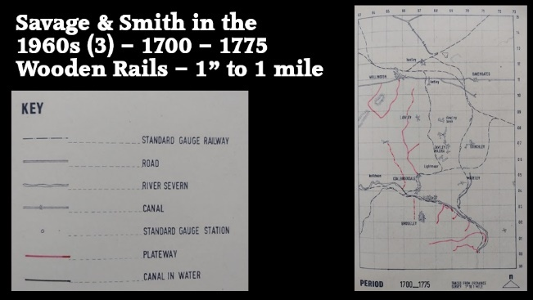
Slide 26 – This second slide covers the period from 1700 to 1775. [6: p81] There is a proliferation of short tramroads which lead down to the Severn and two other lines.
The lines closest to Wellington were associated with the “Steeraway lime kilns and are known from a map within Lord Forrester’s collection c. 1750. … The roads marked as ‘railways’ … consisting of three straight sections together forming a loop joining Watling Street at two points.” [6: p124] There is also evidence in the accounts books of the lime kilns in which several terms relating to the ‘railway’ are used.
The long line shown running from North of Lawley to Coalbrookdale is the route of the Coalbrookdale Company’s first tramroad which brought materials to their works in Coalbrookdale. Savage and Smith struggled to confirm the actual route of the line, although they found some records which suggest that there was an inclined plane down Jigger’s Bank into Coalbrookdale at this early stage.
Savage and Smith refer to a branch line to Horsehay which is probably that shown on the traced map. They also talk of the route North of that branch line going through New Works and probably being extended to Ketley (probably between 1759 and 1762). [6: p129-130]
The other lines on this sheet all follow a pattern typical of many short tramroads in the 18th century and lead directly from a mine to a water course. In this case the River Severn.
There appears, however, to be one set of lines not shown on the map – The Jackfield Rails. It is not clear to me why Savage and Smith did not include these lines on this 1” map. Later in their study, they do provide a larger scale drawing of the lines close to the Severn. [6: p116] Savage and Smith talk of the lines being “known accurately from a survey in the possession of Shrewsbury Borough Library called the ‘Map and Admeasurement of the Broseley Hall Estate’ in two volumes, dated 1728, and with subsequent additions and observations. In all cases the rails seem to be part of the original drawing, although the volumes, which are copies, differ with respect to some of the branches. Altogether six branches seem to be involved and the line runs North downhill through Mone Wood to Jackfield Wharf where it divides four sidings.” [6: p117]
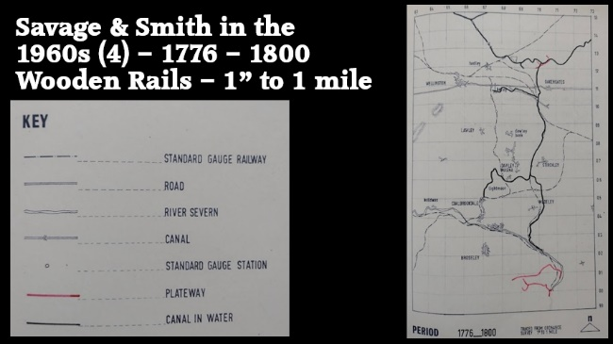
Slide 27 – This third slide covers the period from 1776 to1800 and is the last relating to the earliest wooden tramroads. [6: p83] The marked change from the earlier part of the 18th century is the introduction of the canal system. The Shropshire Union Canal, Shrewsbury Branch ran East-West, generally above the area of Savage and Smith’s mapping. Just a very short section appears at the top of their map.
The black lines on this map show the canals, particularly the Shropshire Canal and its branches to Donnington Wood, Lilleshall, Wombridge, Trench, Ketley, Horsehay and Coalport. These were tub-boat canals and not suitable for the larger narrowboats familiar across the wider canal network in the UK. They did not rely on locks, as water was in relatively short supply, but rather had a series of Inclined Planes up and down which the tub-boats would travel.
These canals were all completed towards the end of the 18th century. Savage and Smith only found two tramroads which were built in this period. Both were to the South of their area of interest.
One connected New Willey Furnaces, Riddings, Swinhey and a Wharf on the River Severn. The other, just a little to the South, connected Grove Coppice and Lower Snett to a Wharf at Bagley Rough on the River Severn and known at the Caughley Railway [6: p134-140] or the Tarbatch Dingle Tramway. [31]
The Benthall Railway (sometimes referred to as Benthall Rails) is believed to have been in existence by 1686. In the late 18th century, the New Willey Company used it, as an alternative to the Tarbatch Dingle Railway, [31] to carry iron to a Severn wharf. At that time the line probably ran from New Willey Furnace North to near Benthall ferry, perhaps to Bower Yard, upstream from the Iron Bridge. (In 1777-80 the Iron Bridge replaced Benthall ferry as the main crossing of the Severn). The southern part of the line probably fell into disuse when New Willey Ironworks closed in the early 19th century, but the northern section probably took limestone and the products of Benthall's ironworks to the river until 1856 or later. [32]
A single reference dated 1774: John Wilkinson for 10 tons of melting iron to the bottom of Benthall Railway. We must suppose this was another route belonging to the Willey Company and presumably starting at Dean Corner (New Willey Furnace) to the Severn (3).
Willock notes that an old flanged wooden wheel was discovered at Caughley Colliery at the turn of the 20th century. That wheel is now in the Iron Bridge Gorge Museum and on display. Willock’s sketch of the wheel is on this next slide. [24]
We should also note a discovery in 1986 of a wooden wagonway close to Bedlam Furnace which is thought to date from around 1760. [41]
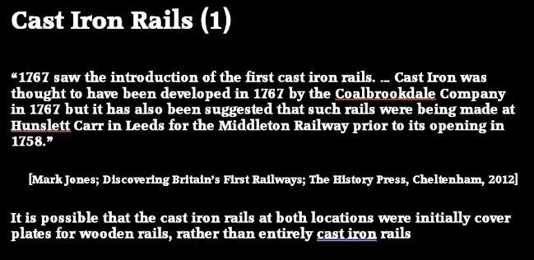
Slide 28 – Iron Railways – In the late 18th century, iron was used for the first time, “either as a running surface applied to wooden rails or as complete rails. Although the initial cost of the iron rail was substantially higher than wood, such rails were typically considered to have lower friction and maintenance costs, longer life and a substantial scrap value when worn out.
Two principal forms emerged:

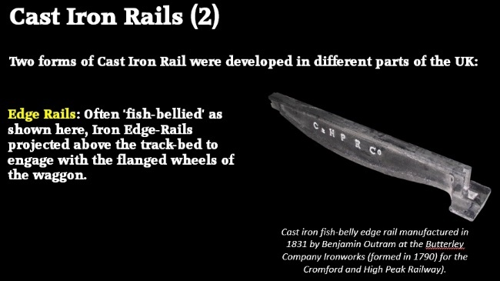
Slide 29 – Iron edge-rails ‒ projecting above the track-bed to engage with the flanged wheels of the waggon. Often used as direct replacements for wooden rails.” [35]

The Image shows a typical Edge Rail - Cast iron fish-belly edge rail manufactured in 1831 by Outram at the Butterley Company Ironworks (formed in 1790) for the Cromford and High Peak Railway). These are smooth edge rails for wheels with flanges.
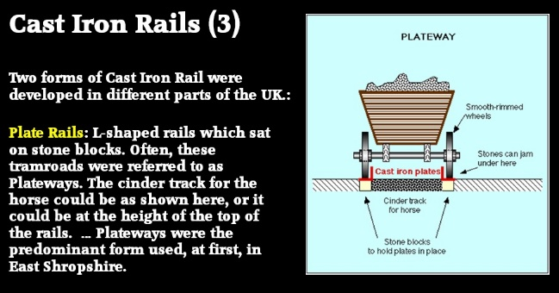
Slide 30 – “Plate-rails (plateway) ‒ an original design of L section for unflanged wheels, which became popular soon after its development in the 1780s. From the mid-19th century, the form was generally superseded overground by the edge-rail.” [35]
The first use of cast-iron rails on tramroads is recorded as being at Coalbrookdale. The Tramroad within the Coalbrookdale works is recorded by Historic England as the first ever iron tramroad. Their record states: “It being found that the wooden rails of the tramroad of one mile length, laid in 1757, along which coal and iron were conveyed from one part of the works to another as well as to the landing places along the River Severn, soon became decayed or broken, after experiments, the rails were replaced in 1767 by rails of cast iron.” [29]
The introduction of steam engines for powering blast air to blast furnaces led to a large increase in British iron production after the mid-1750s. [36][37: p123–25]

“In the late 1760s, the Coalbrookdale Company began to fix plates of cast iron to the upper surface of wooden rails, which increased their durability and load-bearing ability. At first only balloon loops could be used for turning wagons, but later, movable points were introduced that allowed passing loops to be created.” [36][38]

“A system was introduced in which unflanged wheels ran on L-shaped metal plates – these became known as plateways. John Curr, a Sheffield colliery manager, invented this flanged rail in 1787, though the exact date of this is [uncertain]. The plate rail was taken up by Benjamin Outram for wagonways serving his canals, manufacturing them at his Butterley ironworks. In 1803, William Jessop opened the Surrey Iron Railway … in south London.” [36][39]

In 1789, William Jessop had introduced a form of all-iron edge rail and flanged wheels for an extension to the Charnwood Forest Canal at Nanpantan, Loughborough, Leicestershire. In 1790, Jessop and his partner Outram began to manufacture edge-rails. Jessop became a partner in the Butterley Company in 1790. The first public edgeway (thus also first public railway) built was the Lake Lock Rail Road in 1796. Although the primary purpose of the line was to carry coal, it also carried passengers. [36]

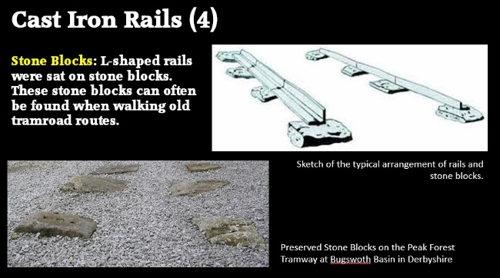
Slide 31 – Stone Blocks: L-shaped rails usually sat on stone blocks. These stone blocks can often be found when walking old tramroad routes.

The images top-right shows the typical arrangement of rails and stone blocks. That bottom-left shows preserved Stone Blocks on the Peak Forest Tramway at Bugswoth Basin in Derbyshire.

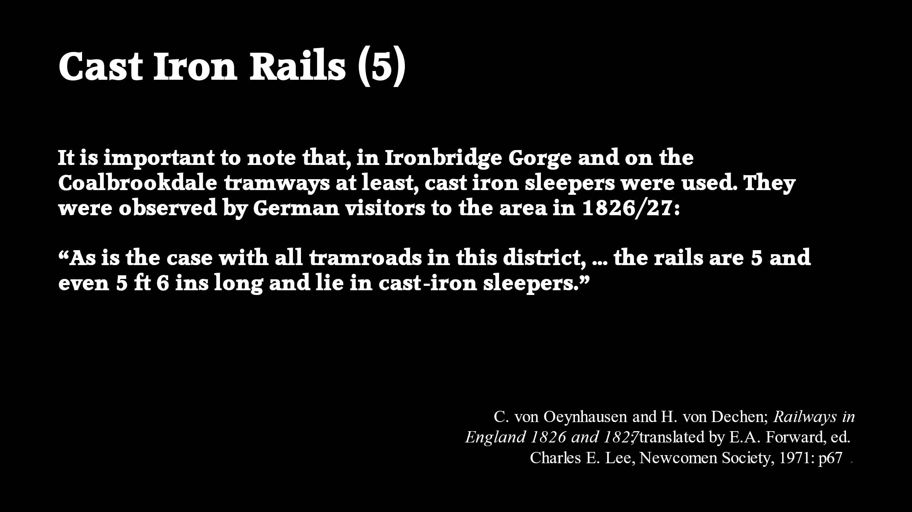
Slide 32 – Cast Iron Sleepers: However, it is important to note that, in Ironbridge Gorge and on the Coalbrookdale tramways at least, cast iron sleepers were used. They were observed by German visitors to the area in 1826/27:

“As is the case with all tramroads in this district, it belongs to the same species. The rails are 5 and even 5½ ft long and lie in cast-iron sleepers.” [34: p67]

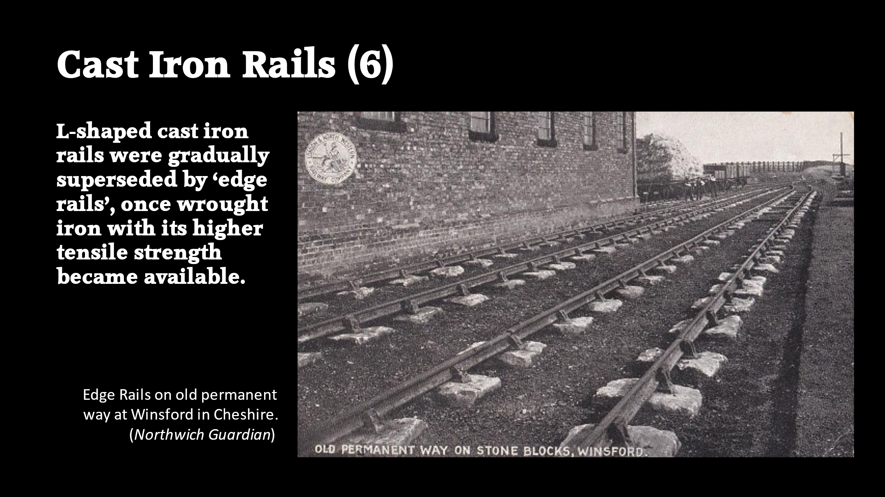
Slide 33 – L-shaped cast iron rails were gradually superseded by ‘edge rails’, once wrought iron, with its higher tensile strength, became available.

The image shows Edge Rails on old permanent way at Winsford in Cheshire.

These two systems, the "L" plate-rail and the smooth edge-rail, continued to exist side by side into the early 19th century. The flanged wheel and edge-rail eventually proved its superiority and became the standard for railways above ground. [40]

These next slides show the introduction of iron rails into East Shropshire.
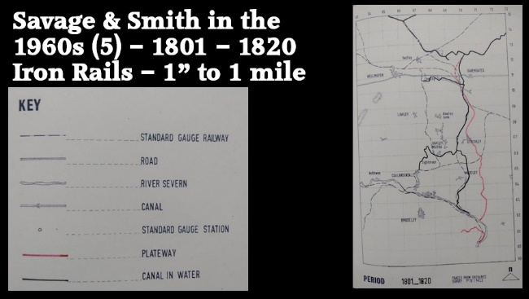
Slide 34 – This map covers the period from 1801 to 1820 and shows two tramroads. [6: p85] The longer of these was a tramroad that met the River Severn at Sutton Wharf and ran up what is now the East side of the Town Park, across Dark Lane, through/round Oakengates on the approximate line of the modern railway. Then, according to Savage and Smith, its probable route swung to the Northeast to meet the Shropshire Canal North of Oakengates.
Bob Yate, in his history of the Lilleshall Company’s Railway and Tramroads, The Railways and Locomotives of the Lilleshall Company, says that this short-lived line “was working by 1799, running from Sutton Wharf, near Coalport, to Hollinswood, where it connected with several ironworks and mines to the north in the area of Priorslee. The total length of this line was about eight miles, and it … [was] horse worked. Bishton and Onions, whose ironworks was situated at Snedshill, were certainly involved in the original line, and by 1812 it had become the property of the [Lilleshall] Company. This is recorded on Robert Baugh's map of 1808, and again on the Ordnance Survey maps of 1814 and 1817, although in the latter two cases it is not shown in its entirety." [33: p35]
Yate explains that the Shropshire Canal sought the business of the Lilleshall Company in the early years of the 19th century and that by 1815 those entreaties had become successful. The Lilleshall Company “agreed that the tramway would be removed, and that its business would be transferred to the canal. In turn, the Company: received compensation of some £500, as well as favourable tonnage rates." [1: p35]
The other line shown on Slide 33 is a revised alignment of what was the line between New Willey Furnaces, Riddings, Swinhey and a Wharf on the River Severn.
In 1800, it appears that the lease on the tramroad route to New Willey Furnace expired. “By 1805, all the equipment had been removed leaving simply the last part of the line from Swinbatch Farm to the Wharf and this line is shown on an indenture dated 10th August 1813, in which the landlord Forester leased rails to: ‘John Langley and his workmen with Jenny Waggons and horses to pass and repass on the said road’. A short length of rail was added at the Swinbatch end to serve the two pits there.” [6: p135]
“It appears that soon after this a new line was built, from pits on the south of Swinbatch Farm to Upper Riding farm by a route south of the old line and from Upper Ridding Farm to Broseley. If this line did not join up with the Tarbatch Dingle remnant, there is no reason to suppose it will have been built on the traditional wooden pattern; the 1” Ordnance Survey of 1833 is difficult to interpret in this case and Greenwood’s map, 1827 show the two sections joined. The map of the ‘Shropshire railway’ in 1836 shows the upper section only.” [6: p135]
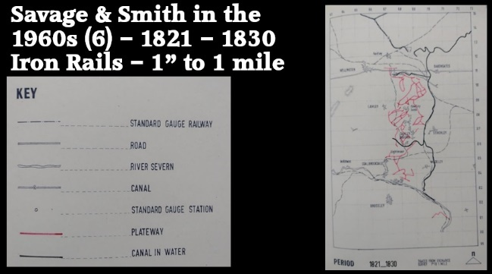
Slide 35 – covers just one decade from 1821 to 1830. [6: p87] The building of the canals towards the end of the 18th century saw increased prosperity in East Shropshire and spawned an incredible increase in tramroad provision. This map, covering the 1820s highlights just how significant a change occurred. For this decade, Savage and Smith took their information from two sources: Greenwood’s Map of Shropshire (1826-27) [19] and a German publication, Oynhousen & Dechen; Uber Scheinwege in Engeland, (1829) which was translated into English by E.A. Forward. [34]
Detailed consideration of all these tramroads is for another occasion. However, it is worth noting the more significant developments in the decade:
- To the South of our area of interest is the truncated version of the tramroad which once served New Willey Furnace which we have just discussed.

- Immediately to the North of the Severn Gorge are tramroads in the Lincoln Hill, Frogmeadow and Bedlam area which appear to have connected into the Coalbrookdale Company’s network.

- The Coalbrookdale Company’s tramroads which extended North from Dale End through Coalbrookdale Iron Works on to the Lightmoor area and Dawley Magna with connections to the Shropshire Canal Coalbrookdale Branch which ran to the South of Dawley Magna. Savage and Smith record that Greenwood’s map of 1827, “shows the link with Lightmoor and an extension to the branch canal (or near it) at Dawley Castle. …The route down the Dale was very easy, and it would have been foolish to carry goods across Lincoln Hill to Frogmeadow and Bedlam instead. … A branch is shown somewhere in the vicinity of the New Pool, and this probably went to Cherry Tree Hill brickworks, … founded before 1825.” [6: p148]
"The earliest description of the new plateway is based on the visit of Oynhausen and Dechen to Coalbrookdale in 1826 or 1827. 'In Coalbrookdale there is a cast iron tramroad extending from the Severn as far as the lower Ironworks of the Dale Company, which, like all the tramroads laid down in this district, is of this kind; the tram plates are 5 and even 5 feet long and lie in cast iron chairs. The tramroad at Coalbrookdale really comprises two: a small one of 20 inches gauge, which is worked with small receptacles, lies in the middle of a large one of 36 inches gauge. It is worked by horse traction and it deserves to be mentioned that here in this neighbourhood the narrowest gauge which is anywhere to be found is employed for horses, on some roads it only attains 18 inches'." [6: p151]
At Lightmoor, "the lines marked on Greenwood's map. [1827] are extensive, but there is no link with Horsehay. A line runs to the Coalbrookdale branch canal near Dawley Castle and another ... goes to Lincoln Hill. A line from Horsehay comes near Cherry Tree Hill brickworks, but is shown no further than the Lightmoor-Stoneyhill road, along which it may have continued. A collection of sidings suggesting a mine are shown near Dawley Castle." [6: p149]
- Around Dawley Bank and further North there was a significant network of tramroads which seems to link to the Shropshire Canal to the Northwest of Stirchley. "The question of routes to Coalbrookdale from the areas to the North is tied up with the decline and gradual disuse of the Coalbrookdale branch canal. In 1800 the canal and the terminal Inclined Plane at Brierly Hill were in full use for the purpose of sending down coals and iron for exportation, and for the use of the works at Coalbrookdale, and for bringing up limestone for the use of various Ironworks on the summit level of the canal, and about Ketley and the Oaken Gates." [6: p151] Greenwood’s 1827 map shows Old Park Furnaces in this area, “served by numerous tramways, mostly in Old Park, but with long branches to Snedshill and to the canal at Hinkshay.” [6: p165]

- Oakengates: “Greenwood's map shows numerous sidings in the vicinity of Stafford Street, Oakengates, and a long line taking a very indirect route to Old Park.” [6: p143]

- At Horsehay and Dawley, "the system of railways shown on Greenwood's map is vast, but almost totally unidentifiable on a modern map. Horsehay Pool is shown and the position of the ironworks can be seen. A maze of lines suggest extensive mining between Horsehay and Dawley Bank; a line, already mentioned, goes to the vicinity of Cherry Tree Hill brickworks; another indirectly to near Dawley Castle furnaces (1810-33), and another to The Finger." [6: p150]

- The Ketley furnaces were part of the earlier Coalbrookdale network, but, once under separate management they seem to have been excluded from the newer Coalbrookdale network. [6: p151] “Greenwood shows a line from Ketley Ironworks to near Steeraway with a branch to Lawley and New Works. An Ironworks separate to Ketley Ironworks is served by lines running to the vicinity of Ketley Town Halt, possibly with a branch across Watling Street to join the complicated New Hadley series.” [6: p145]
The proliferation of Tramroads continued beyond 1830 as we can see on the next slide.
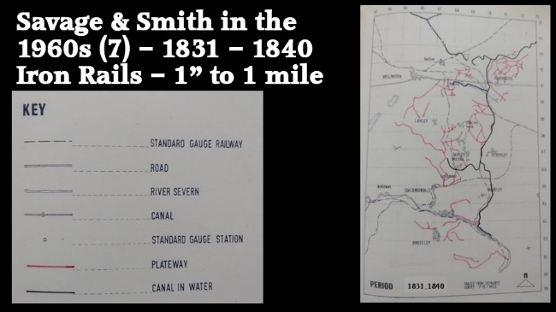
Slide 36 – covers the decade 1831-1840. [6: p89] The documents relating to this decade which were available to Savage and Smith included: the 1” Ordnance Survey of 1833; A Map of the Shropshire Railway (1836); a Stirchley Tithe Map; a Little Dawley Tithe Map (1840); and a Broseley Tithe Map (1840). [6: p88]
South of The River Severn we can see that what was the Willey, Riddings and Swinhey Tramroad seems to have developed further at its Western end. However, Savage and Smith have very little to say about this line, except to note that the 1” Ordnance Survey of 1833 is difficult to interpret.
Other lines are shown on the South side of the Severn:
- There are lines shown to the East of Corbett’s Dingle which are difficult to relate to ground-features on OS Maps and on which, Savage and Smith appear to provide no notes.

- Corbett’s Dingle is immediately to the South of the Duke of Wellington Inn. The tramroad followed the valley and so is shaped like an elongated, mirrored ‘S’

- The Much Wenlock Lines: the first part of which, close to the Severn, can be seen on the extreme western edge of the map. The railway “appears on Greenwood’s map of 1827, the one inch Ordnance Survey of 1833, and the half-inch Shropshire Railway map of 1836. From the latter two it can be enlarged and plotted. It seems to go to some pits and [was] presumably [used] simply to bring coals for Severn sale.” [6: p168]

- Broseley: there are short lines shown on the Northwest side of Broseley village. These are Benthall Rails. Savage and Smith note that the rails from Benthall Edge to Broseley clay pipe-works are shown on both the 1833 OS Map and the 1836 Shropshire Railway map. [6: p176]
North of the Severn:
- Madeley Wood: on the North bank of the Severn, directly opposite the Corbett’s Dingle line, in the Madeley Wood area, is an element of what became a larger network centred on Bedlam. Greenwood shows a line from Lincoln Hill/Styches Colliery to Meadowpit Colliery, which joins at line at the Severn between Bedlam and The Lloyds. [6: p159] Savage and Smith note that the one inch Ordnance Survey, “shows far fewer tramways than Greenwood, probably on account of the greater quantity of the other detail. The only Greenwood line which has definitely been removed in the period 1827-33 is the one to Lightmoor; there is no other conflicting detail on the ordnance survey to explain its absence. The line from Bedlam to the Lloyds has been extended to pits near Blists Hill.” [6: p160] … The map of 1836 of the Shropshire Railway from Shrewsbury to Wolverhampton (which was never built) shows lines mentioned above. Savage and Smith say: “The standard of draftsmanship of this map is very good, the survey work being presumably based on the ordnance survey, so we feel confident in scaling up the detail.” [6: p160] In their text, Savage and Smith first produce the series of maps that we are looking at and then go on to pick specific networks or ‘series’ of tramroads to draw at a scale of 6” to the mile. Looking at these will need to be for another occasion.

- Lightmoor and the Coalbrookdale Tramroads: The 1833 OS Map shows the Coalbrookdale part of the line to Lightmoor and agrees very well with later maps. The 1836 Shropshire Railway map shows pieces of the whole line from Lightmoor to the River Severn which suggests that shown on later maps but without any detail. [6: p148]

- Stirchley and Old Park: Savage and Smith say that the 1” Ordnance Survey of 1833, shows a link to Hinkshay and continues it North along the Canal to Wharf Colliery. The 1836 Shropshire railway map shows two routes from Old Park to Hinkshay and two routes from Old Park to the Canal at Dark Lane and Hollinswood.” [6: p165] It seems to me that Savage and Smith may be conflating two different locations. At the time of Greenwood’s map referred to under Map 5, Old Park Furnaces are North of Malinslee. At the time of the 1” Ordnance Survey a few years later a second Old Park Furnaces site has opened further to the South, closer to Stirchley village and on the East side of the Canal close to the location of Stirchley Furnaces.

- Coalmoor: The lone line running Northwest from Lightmoor runs to Coalmoor which appears to join with the Coalbrookdale lines may or may not do so. The tramroad route appears on both the 1833 OS map and the 1836 Shropshire Railway map but the route on each is marginally different.

- Horsehay, Horsehay Common, Lawley Common and Heath Hill: “the 1” OS map shows a line [North from Horsehay towards Lawley Common to the West of Heath Hill], with branches to pits; Horsehay [towards Dawley Castle]; probably a railway from [Horsehay] to the nearest point on the canal, where it [was] joined by a long branch coming from Huntington, [not so far from what was Doseley Quarry]. A line very similar to the later line … seems to go from pits at Heath Hill to the canal at Dawley Castle. This last line may not have joined up with the rest.” [6: p150]

“There is no sign of the Huntington line in 1827, … but it appears on both the one inch ordnance survey of 1833 and the half inch Shropshire Railway map of 1836. It was probably part of the Horsehay series, though this cannot be said with certainty. It evidently brought limestone from near the Wrekin.” [6: p174]. It seems to connect with the end of the Coalbrookdale Branch of the Canal which is shown close to Horsehay.

- Lawley and Ketley: Immediately to the South of Watling Street (the Chester to Holyhead Road), the map shows a series of lines to the Southwest of Ketley and the North of Lawley. Savage and Smith comment: “The one inch Ordanace Survey [1833] shows the line to near Steeraway [referred to in the notes for Map 5], but it is not clear which roads in the immediate vicinity of the furnaces are meant as railways. A fragment of line from pits to the West of New Works runs to Lawley Furnace, but does not continue to Ketley.” [6: p145]

- “The Shropshire Railway map [1836] shows the line to near Steeraway running through Short Wood into Limekiln Wood, with branches to Black Hayes and New Works. At New Works, on the other side of the road to Arleston Hill, a line goes to Lawley Furnace.” [6: p145]

- Snedshill and Priorslee: Savage and Smith comment that on both the 1833 one inch ordnance survey and the 1836 Sharopshire Railway map, “Rail Roads are marked going along Freestone Avenue to pits three hundred yards from Priorslee Hall and to Woodhouse Colliery. A branch goes to pits which are to the east of Stafford Street and north of Freestone Avenue. The line continues northward crossing Station Hill just to the east of the canal and continues to Wrockwardine Wood inclined plane.” [6: p143]
North of Watling Street, the map shows two concentrations of Tramroads, a smaller series North of Ketley and a more significant series around Oakengates.
- North of Ketley: Ketley was served by the Shropshire Canal Ketley Branch. The tramroads to the North of Ketley appear to connect to that Canal branch. “New Hadley furnace, started before 1833, is the focus of a few lines.” [6: p178]

- Oakengates: Savage and Smith provide some notes on tramroads in the area of Snedshill and Priorslee which are South of Watling Street and which are covered above, but they seems not to have provided detailed notes on the proliferation of tramroads North of Oakengates. This is the full text relating to that area: “At Donnington Wood Ironworks the Shropshire canal is connected by an Incline Plane to the Ironbridge canal and its continuation Lord Stafford's canal. A railway ran under the Incline Plane in 1792, according to Deposited - Plan 289. Information in the possession of W. Howard Williams shows this line continued north and then west to run to the north of the Iron Works and Glass House. … Our only clear evidence of lines in the early nineteenth century is the half inch map of the Shropshire Railway.” [6: p178]
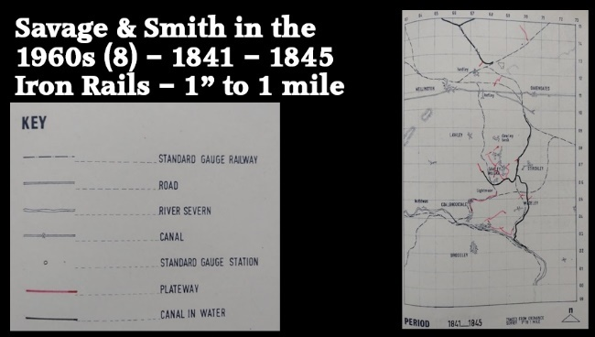
Slide 37 – This map covers a five-year period from 1841 to 1845. [6: p91] It indicates only limited adjustments to the network of tramroads. The canal network was by this time significantly truncated in the North of the area and, apart from Hadley Furnaces, local industrial sites no longer had access to the national canal network. For some years access to national markets would have been limited to road transport and the Coalport Branch of the Canal to the River Severn.
Savage and Smith record changes to the tramroads in just 4 areas:
- The Coalbrookdale Network which includes Dawley, Lightmoor and Coalbrookdale: Savage and Smith believe that by this time, rather than procuring materials for Lightmoor Furnaces from across the River Severn in Benthall, these were, by 1845, being sourced from the Dawley area. [6: p153] Various alterations to the local network were made by this time.

- The Madeley Court area: various minor tramroads were in place linking with the Coalport Branch of the Shropshire Canal.

- The Madeley Wood area and the network centred on Bedlam Furnace: again only minor alterations in the first half of the 1840s.

- North of Watling Street, only small changes near Handley Furnaces and Ketley are noted. A tramroad link to the Humber Arm of the Shropshire Union Canal appears, top right. These are shown on the plan but not remarked on in Savage and Smith’s notes.
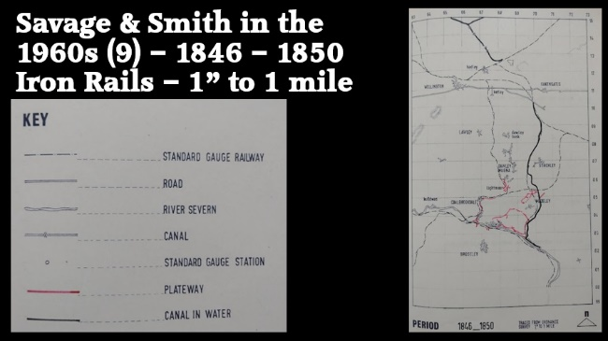
Slide 38 – This map covers another five-year period from 1846 to 1850. [6: p93] As is evident on the plan, Savage and Smith record no additions to the network North of Watling Street. They do record changes in the canal network again. The Coalbrookdale Branch of the Shropshire Canal has been removed from the plan having fallen into disuse in the 1840s.
The changes to the tramroad network which Savage and Smith show are:
- The Coalbrookdale Company’s network in Coalbrookdale and at Lightmoor – small additions are show North of Lightmoor and the main Coalbrookdale tramroad is highlighted too. Savage and Smith note that deposited plan No. 325 (1845) “shows a series of line at Lightmoor furnaces and suggests a branch in the direction of Dawley” [6: p149] and “the beginning of a line to Coalbrookdale.” [6: p148] “Deposited plan 338 (1845) shows a line from Coalbrookdale going as far as [a point Northeast of Lightmoor Furnaces].” [6: p148 & p149] These deposited plans appear to be records of existing lines rather than of developments or changes.

- Minor changes South of the River Severn – Savage and Smith note two small sections of tramroad which appear on the 1846 Deposited Plan No. 346. These are those located directly North of Broseley. To the West, opposite Dale End, Savage and Smith have shown a short section of tramroad which appears to divide close to the Severn. I cannot find reference to this anywhere other than on Map 8.

- Madeley Wood/Bedlam – the Madeley Parish Tithe map of 1849, the potential ring of tramways formed, but with definite breaks and, therefore, possible differences in rail type and gauge. From Lincoln Hill to Meadowpit Colliery, is one section; from Meadowpit Colliery to the Canal, from Blists Hill to Bedlam with sidings at the Lloyds, a small piece Above Bedlam to the Northeast close to the Brick and Tile Works at Lincoln Hill.

- Madeley Court – significant tramroad construction took place towards the end of the 1840s. The Madeley Court series of tramroads served Madeley Court Ironworks and its two collieries. Savage and Smith comment that, “these collieries are on the barren Upper coal measures which have to be penetrated to reach the middle coal. This side of the coalfield was neglected in the early times in preference for the west half of the coalfield where the middle coal is near the surface. There is no sign of mineworking here until 1846 when the furnaces are shown on Deposited Plan 340 with links to the near part of Madeley Court Colliery, to the main road (A442) and to Tweedale where the same road crosses the canal to Coalport. … In 1849 the part of the colliery southwest of the Court is shown in use on the Tithe Map.” [6: p181]

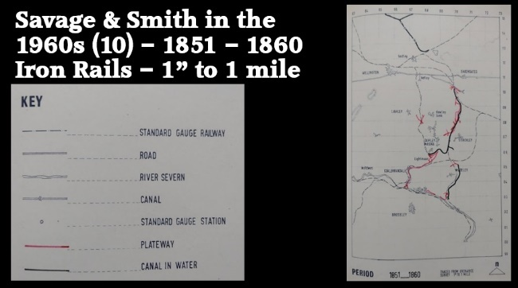
Slide 39 – This map shows the decade 1851 to 1860. [6: p95] In 1854, the Standard-Gauge Railway to Lightmoor from Madeley Court was opened. In 1861 it was joined at Lightmoor by the Railway from Wellington, and in 1864 continued through Coalbrookdale to join the Severn Valley Railway at Buildwas.
Some adaptation of tramroad lines was necessary to accommodate the new railways, including the provision of an under-bridge for the tramroad near Oilhouse Coppice as seen in the picture taken by Savage and Smith in the 1960s. “At first the plateways were treated as branches to the Standard Gauge Railways, as they had earlier been branches to canals, with transfer sidings where necessary.” [6: p154]
Savage and Smith note that the map records information from Deposited Plans from 1852 numbered 348, 349, 350, 351 and 367, and the Madeley Junction to Lightmoor Railway plans of 1854. Nothing is noted South of the River Severn, nor North of Watling Street.
Prominent on the map are:
- The Coalbrookdale to Lightmoor Tramroads – at Lightmoor: Deposited Plan 350 of 1852 shows passing loops at Lightmoor brickworks and an elaborate series of sidings at Lightmoor furnaces with three lines leading to Dawley Castle; and Deposited Plan 351, also of 1852, shows the line to Dawley Parva complete, ending in a series of branches. Savage and Smith comment: “In 1852 there is evidence of a line from Lightmoor to Dawley Parva and a new one perhaps to Lightmoor Colliery. The line towards Dawley Castle is still in existence, with a branch to the north of Lightmoor furnaces. A small branch goes to an area a hundred yards north of Moor Farm.” [6: p153]

- Tramroads associated with the Shropshire Canal from Northwest of Stirchley and running further to the North. These are detailed on Deposited Plan 367 and include tramroads relating to Stirchley Ironworks and Jerry Furnace. Savage and Smith comment: “By 1856, there is a considerable amount of industry along the canal from Hinkshay to Shedshill. The upper reservoir at Hinkshay had appeared before 1833, but the site of the lower reservoir was in 1856 just a small canal basin with a line running to it probably from Langleyfield Colliery. A line from Jerry Furnaces to the ironworks at the rear of New Row crosses it at right angles and a common type and gauge of rail cannot be assumed. This second railway from Jerry Furnaces reverses and continues in to Stirchley Furnaces.” [6: p166]

Savage and Smith continue: “To the north of Stirchley Furnaces the line runs on the west side of the canal on the towpath. There is a branch near Stone Row, perhaps to pits; to Randley Brickworks and perhaps to pits to the north of the brick- works; to Wharf Colliery and Lodge Colliery; past Dark Lane Foundry; to old Darklane Colliery and Lawn Colliery with a branch to old Darklane Brickworks. After a reverse the line carries on to Dudleyhill Colliery and Hollinswood Ironworks.” [6: p166]

- A small group of lines between Lawley and Dawley, Northeast of Horsehay – these are taken from Deposited Plan 350 of 1852.

- Small changes at Madeley Court are shown on Deposited Plans: 351 of 1852; and 367 of 1856. Savage and Smith comment: “A stretch of tramway is shown in 1852 in the far part of Madeley Court Colliery. In 1856 this line is shown to continue back to the furnaces and extends on the other side to a small canal basin at Tweedale. The building of the Madeley Junction to Lightmoor Railway put an end to the Windmill Inclined Plane, but gave the opportunity of having a standard-gauge siding in the Ironworks. This line was opened in 1854…. The building of the Coalport branch railway, opened in 1860, had little effect on the works, but involved the building of a bridge to carry the tramway underneath it.” [6: p181]

- Some details of the Madeley Wood/Bedlam group of tramroads appear on Deposited Plans 348 and 351 of 1852. Much of what may have been a network of tramroads seems to have been split up to a certain extent by 1850. [6: p161]
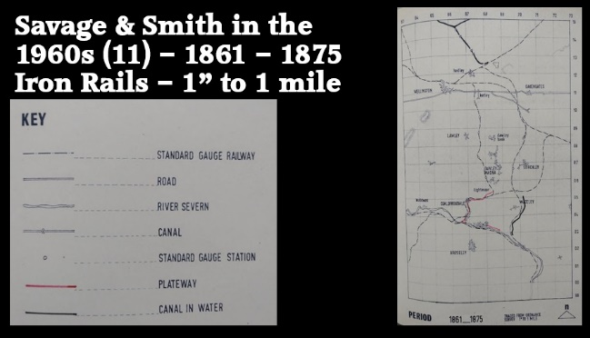
Slide 40 – the map records the period from 1861 to 1875. [6: p97] Savage and Smith note that it records information from Deposited Plan No. 399 (date not given) and three sets of railway plans:
- the Severn Valley Railway which opened on 1st February 1862;
- the Much Wenlock and Severn Valley Railway which also opened on 11st February 1862; and
- the Lightmoor to Severn Valley Railway which opened on 1st November 1864.
By the end of this period, the Shropshire Canal was no longer in use. Savage and Smith have removed it from the map, with the exception of the length from Madeley to the River Severn.
Other than the Canal, there are just two areas to note:
- The Coalbrookdale to Lightmoor Tramroads – the Line from Dale End to Lightmoor is featured on the map but shows no significant changes.

- Bedlam – Savage and Smith record a tramroad along the North bank of the River Severn.
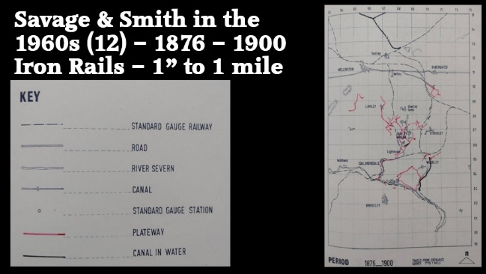
Slide 41 – records the period from 1876 to 1900 [6: p99] and includes information from:
- the 6” Ordnance Survey of 1880
- the 25” Ordnance Survey from 1881
- the GWR Survey of 1881
- further Ordnance Survey plans local to:
  - Stirchley – 1882
  - Dawley – 1882
  - Ironbridge – 1882
  - Madeley Court – 1883
  - Madeley Court Ironworks and Colliery – 1883.
This map is more heavily populated by red lines than the last one. Things to note include:
- The Coalbrookdale to Lightmoor Tramroads – the Line from Dale End to Lightmoor is featured on the map but shows no significant changes. Savage and Smith comment that the 25” Ordnance Survey of 1882 shows “the link between Lightmoor and Horsehay via Dawley, with a branch from Dawley Castle to pits at Southall and a continuation towards The Finger” [6: p150]

- Horsehay – Savage and Smith comment that at Horsehay by 1881, “there were several standard gauge sidings, but most of the internal transport of the works was by plateway, of which there was about 25 sidings. As buildings were replaced and replanned to accommodate the gentler curves of Standard Gauge track, the tramways could be replaced, but they survived for internal use until very recently. … The 1882 Ordnance Survey shows a link between Horsehay and Coalbrookdale, and therefore a common gauge and rail type. It is not known whether one or other section had to be relaid to achieve this.” [6: p154] The 1882 OS map also shows lines: from Horsehay to Doseley Quarry; to pits in Dawley Parva; to New Street, Dawley; to Wellington Road and continuing to Lawley; to Horsehay Common; and a number of other short branches. [6: p150]

- Bedlam/Madeley Wood – Savage and Smith comment that by 1882, “The whole circle through Lincoln Hill, Meadowpit Colliery, Blists Hill and Bedlam is now complete.” [6: p160] This suggests that the routes which in 1850 were not used greatly beyond immediately local connections have become a network by 1882. They further comment that the 1882 25” OS Map “shows all the various sections of the ring linked up, a new branch line to Madeley Hill brick and tile works and the line through Styches Colliery to Bedlam rebuilt. The junction of this line at the north end is different, suggesting that at some time it had all been removed in the period between 1849 and 1882. The new junction is suitable for traffic to and from the Madeley direction.” [6: p161]

- Madeley Court – Savage and Smith record two lines in this period – a line running East from the furnaces across the North side of Halesfield Colliery and an equivalent line running Southwest. These lines remain visible on the 1901 revision of the 25” Ordnance Survey.

- Steeraway – Savage and Smith note two lines which appear on the 1885 6” ordnance survey. The 6” map of 1925 describes them as "old tramway".

- South of Oakengates – tramroads are shown to the Southeast of Priorslee Furnaces. The 6” Ordnance Survey of 1903 shows the bottom arm at this location linking Darklane Colliery to the Furnaces. The upper arm is shown on the 6” Ordnance Survey of 1885 as serving a colliery adjacent to the Lion Inn. The tramroad link to the colliery is not shown on the later survey.

- Stirchley and Jerry Furnaces – on this map, have tramroad links to the Standard-Gauge Coalport Branch of the LNWR which opened by June 1861.

- South of the River Severn – Savage and Smith show three locations relevant to this time period with short tramroads close to the South bank of the Severn. They seem not to provide any relevant notes.
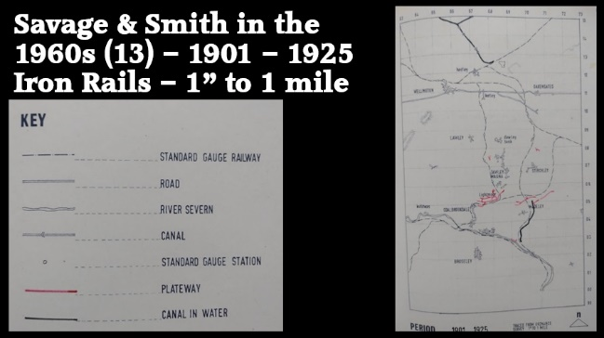
Slide 42 – covers the period from 1901 to 1925. [6: p101] It is the last of Savage & Smith’s 1” to the mile plans and includes information from:
- A series of different Ordnance Survey plans from the early years of the 20th century, specifically:
  - The 1907 revision to the 1881 25” Ordnance Survey.
  - Plan XLIII 10 – SE (enlarged for the Inland Revenue) of 1901
  - Plans XLIII 3 – NE and XLIII 3 – NE, both of 1911
  - Plan XLIII 6 – SE (No date provided)
  - Plan XLIII 10 – NE (No date provided)
  - Plan XLIII 6 – NE (No date provided)
  - Plan XLIII 11 – SW (No date provided)
  - Plan XLIII 15 – SE (No date provided)
- The Stirchley Apportionment plan of 1924
- The 6” Ordnance Survey of 1925.
Savage and Smith show 5 locations which saw changes in tramroads during this period:
- The Coalbrookdale to Lightmoor Tramroads – a significant network of tramroads developed from transfer sidings to the standard-gauge line at Lightmoor. “The revised large scale ordnance survey [of 1901] shows branches from Lightmoor to collieries a third of a mile north of the Lightmoor Brickworks; … to Strutfield Brick and Tile Works (started before 1825); and to Cherry Tree Hill Brick and Tile Works.” [6: p150]

- Madeley Court – Savage and Smith note just a small change to the network in the area immediately South of Maeley Court itself. [6: p180-181]

- Horsehay – Savage and Smith record a minor alteration on Map 12 [6: p101] but make no comment on this in their discussion. [6: p154]

- North of Stirchley – one minor change to the tramroads in the vicinity of the LNWR Coalport Branch. And the later GWR, Stirchley Branch. Savage and Smith say that, “These railways and their sidings took over the work of the tramways. The skew bridge over the railway at the south end of Randley Pool bears witness to the alterations required to make standard gauge lines to the Malinslee area possible.” [6: p166]

- Madeley Wood – immediately adjacent to the River Severn , one small section of tramroad is highlighted by Savage and Smith on Map 12. [6: p101] They make no comment on this in their discussion. [6: p159-161]

Savage & Smith’s 1” maps show us that the peak period for development of the tramroads in this area was from around 1820 to around 1860.
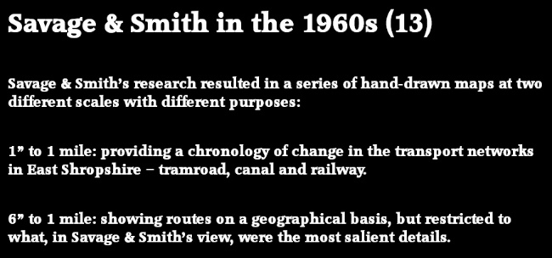
Slide 43 – Savage & Smith used their 1” maps to give a sense of the chronology of change in transport networks in East Shropshire. They then provide a series of 6” to the mile maps which focus on specific routes drawing out what they saw as the most significant details. [6: p103-188]
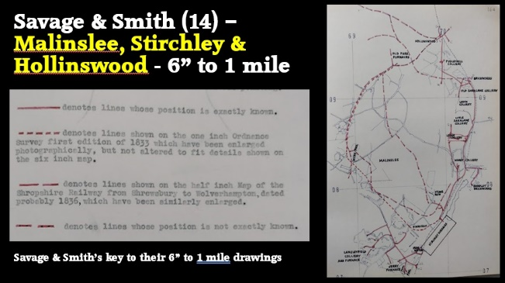
Slide 44 – Malinslee, Stirchley, Old Park and Hollinswood: The first of these plans covers tramroads which Savage and Smith call the ‘Stirchley and Old Park Series’ of tramroads. [6: p164] It should be noted that not all of these lines were in existence at the same time. There is also an area on the drawing which is marked Stirchley Furnaces in which the detail is too complex to show on a 6” to the mile plan.
The solid red lines are those which they could locate relatively precisely. As can be seen, these are lines associated with the Shropshire Canal Coalport Branch and the later LNWR Coalport Branch railway.
The lines shown with longer red dashes are translated from the 1836 Shropshire Railway Map. The scale of that map is relatively small – just ½” to a mile. The shorter red dashes denote lines as drawn on the 1833 1” Ordnance Survey. Enlarging from both of these maps leaves room for discrepancies to be introduced and probably explains some of the differences shown on this first 6” map, specifically in the Hinkshay area.
I am seeking to follow all the lines shown on Savage and Smith’s 6” drawings at present with the aim of verifying actual routes. You can see progress on my blog, ‘rogerfarnworth.com’ if you are interested. I can be a little clearer of the most likely routes of these lines in the areas that I have walked. The relevant completed articles which relate to this area can be found by following these links:
http://rogerfarnworth.com/2022/06/15/ancient-tramroads-near-telford-part-4-malinslee-part-1
http://rogerfarnworth.com/2022/06/24/ancient-tramroads-near-telford-part-6-malinslee-part-2-jerry-rails
The term ‘Jerry Rails’ is unique to the immediate area covered by this article. It was coined in this local area and is not used elsewhere in East Shropshire. Its derivation is unclear but may have something to do with the name given to local furnaces, or the nickname of a local pub. The name is accepted locally but disputed by those with a greater knowledge of the early tramroads of the UK.
http://rogerfarnworth.com/2022/08/11/ancient-tramroads-near-telford-part-7-malinslee-part-3
http://rogerfarnworth.com/2023/02/25/early-tramroads-near-telford-part-9-the-lilleshall-company-tramroad-running-from-sutton-wharf-through-the-area-east-of-malinslee-through-hollinswood-and-oakengates-and-the-companys-early-inte/

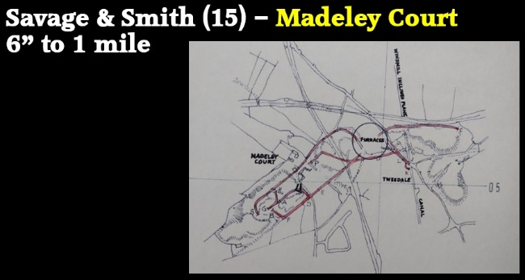
Slide 45 – Madeley Court: A second example of these plans covers tramroads which Savage and Smith call the ‘Madeley Court Series’ of tramroads. [6: p179] It should be noted again that not all of these lines were in existence at the same time.
Savage and Smith were sufficiently confident of the locations and routes shown on their 6” plan to show all the routes in solid red lines. They do not show the detail of the tramroads in the immediate vicinity of the furnaces. Bear in mind, again, that not all the tramroads shown were, necessarily, in use at the same time.
I have yet to look at this area in detail. Savage and Smith’s comment: “The Madeley Court series of tramways served Madeley Court Ironworks and its two collieries. These collieries are on the barren Upper coal measures which have to be penetrated to reach the middle coal. This side of the coalfield was neglected in the early times in preference for the west half of the coalfield where the middle coal is near the surface. There is no sign of mineworking here until 1846 when the furnaces are shown on Deposited Plan 340 with links to the near part of Madeleycourt Colliery, to the main road (A 442) and to Tweedale where the same road crosses the canal to Coalport.” [6: p181]
“In 1849 the part of the colliery south west of the Court is shown in use on the Tithe Map. A stretch of tramway is shown in 1852 in the far part of Madeleycourt Colliery. In 1856 this line is shown to continue back to the furnaces and extends on the other side to a small canal basin at Tweedale.” [6: p181]
“The building of the Madeley Junction to Lightmoor railway put an end to the Windmill Inclined Plane, but gave the opportunity of having a standard gauge siding in the Ironworks. This line was opened in 1854. The building of the Coalport branch railway, opened in 1860, had little effect on the works, but involved the building of a bridge to carry the tramway underneath it.” [6: p181]
“By 1883 a tramway had been carried across the old Inclined Plane to a pit in the colliery north of Halesfield Colliery. The west part of Madeleycourt Colliery was still in use and slight differences in the tramway layout are again noted in 1901.” [6: p181]
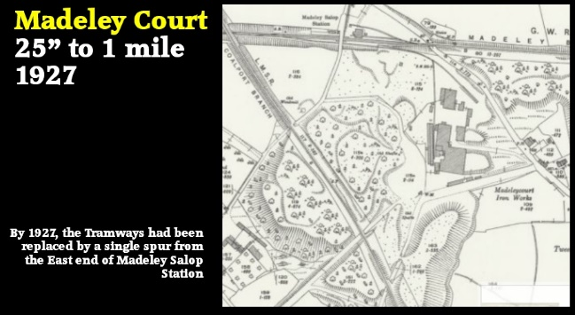
Slide 46 – Madeley Court in 1927 – By the Tramways had been replaced by a single spur from the East end of Madeley Salop Station.

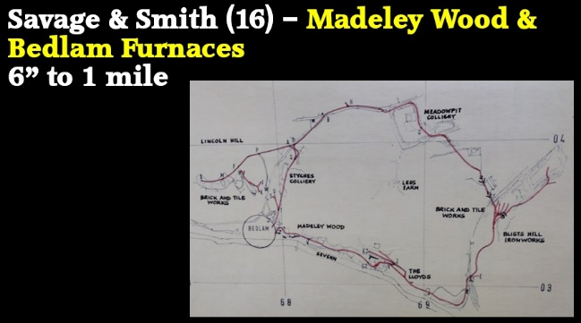
Slide 47 – Madeley Wood and Bedlam Furnaces: This third example of the 6” to the mile plans produced by Savage and Smith [6: p158] covers the area of Madeley Wood and the Bedlam Furnaces on the North side of the River Severn. They refer to this series of tramroads as ‘Madeley Wood’. Once again, they do not show any detail of tramroads in the immediate vicinity of Bedlam Furnaces and we need to continue to bear in mind that not all the tramroads shown were in use constantly or, necessarily, simultaneously.
Again, I have yet to look in detail at this series of tramroads. Savage and Smith comment: “For once the lines shown on Greenwood's map, 1827, agree to some extent with later evidence, but there are two important differences. Firstly, there is a line from Lincoln Hill to Lightmoor, the use of which we will discuss when dealing with Lightmoor. Secondly, there is a continuation of the line from Lincoln Hill to Meadowpit Colliery bringing it back to near Styches Colliery.” [6: p160]
“At Lincoln Hill, the kilns of the Woodland Brick and Tile Company had been started in 1780 and these are probably what are meant by 'tile kiln'. The junction with the line going south through Styches Colliery is so arranged that goods could go straight down without reversing.” [6: p160]
“The line from near Bedlam to the main Ironbridge-Lloyds road may be thought a means of providing an easy zig-zag descent down the hill, but the gradient is no worse than further up the hill, where the line comes straight down regardless. The line towards the Lloyds may have continued on the road without Greenwood troubling to mark it. It would be natural to bring coal and limestone from the Lloyds for Bedlam furnace which, though blown out by Richard Dearman between 1792 and 1803, is shown as probably working in 1833. The lines from Lincoln Hill to Lightmoor and from Meadowpit Colliery to below Styches Colliery disappear by 1833.”” [6: p161]
“By 1847 to 1849 the lines had been split up to a certain extent, and more laid on the east side. The rail from Styches Colliery south to Bedlam disappeared, which is curious, unless one assumes that all the output was taken by the brick and tile works on Lincoln Hill. Madeley Hill brick and tile works is shown for the first time at this date, so the industry is likely to have been prosperous then. A line was added to bring coal from Meadowpit Colliery to Blists Hill. Another line, already built by 1833 as far as pits south of Blists Hill Ironworks, was extended north.” [6: p161]
“The 1882 large scale Ordnance Survey which shows all the various sections of the ring linked up, a new branch line to Madeley Hill brick and tile works, and the line through Styches Colliery to Bedlam rebuilt. The junction of this line at the north end is different, suggesting that at some time it had all been removed in the period between 1849 and 1882. The new junction is suitable for traffic to and from the Madeley direction.” [6: p161]
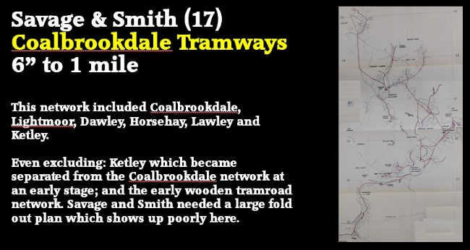
Slide 48 - Coalbrookdale, Lightmoor, Dawley, Horsehay, Lawley and Ketley: This fourth example of the 6” to the mile plans produced by Savage and Smith [6: p158] covers a large area does not show up well on one image without the loss of a great amount of detail. You will have picked up from our discussion so far that this area is large and underwent many changes over the centuries. I have chosen to exclude Ketley from what I show here. Ketley became separated from the Coalbrookdale network of tramroads at an early stage. I have also not included the earliest wooden tramroad network as Savage and Smith chose to deal with this separately from the later tramroads. The wooden tramroad network ran North from Coalbrookdale on the left side of these images. In Savage and Smith’s book the area is covered by a large foldout plan. [6: p146]
For an article on my blog, I looked first at the tramroads which appeared on the on the 1882/83 6" OS Maps (published in 1887) and later surveys. Where evident on those maps, I included older tramway routes. You can find that article here:
http://rogerfarnworth.com/2022/04/26/ancient-tramroads-near-telford-part-2-the-coalbrookdale-company-tramroads-shown-on-the-1882-83-6-os-maps-published-in-1887-and-later-surveys
Once again, Savage & Smith do not provide detailed plans relating to the area immediately around and within the principal sites of Horsehay Ironworks and Lightmoor Furnace and Brickworks.
Unsurprisingly, they have a great deal to say about what they call ‘The Coalbrookdale Series’ of tramroads. The earliest description of these tramroads comes from 1826/1827 and a book written in German by C. von Oeynhausen and H. von Dechen; Railways in England 1826 and 1827, fortunately for us, this was translated into English by E.A. Forward. [34] The full text relevant to East Shropshire is produced in the additional notes below. Savage and Smith quote one section of the translated document:

“In Coalbrookdale, a cast-iron tramroad runs from the Severn to the lower iron smelting works of the Dale Company. As is the case with all tramroads in this district, it belongs to the same species. The rails are 5 and even 5 ft long and lie in cast-iron sleepers. The tramroads at Coalbrookdale are of two sizes. The smaller one is of 20 in. gauge, and the haulage on this is performed with small trucks; it lies in the middle of a larger line of 36 in. gauge. Horse haulage is used thereon. It, perhaps, merits remark that the smallest gauge for horse use employed anywhere is to be found in this district, as on some lines the gauge is only 18 in.” [34: p67]
This quote from Oynhausen and von Dechen mentions three different track gauges 36 in, 20 in and 18 in. We cannot be absolutely sure of the extent of the networks of the different gauges, nor are we able to define the extent of any dual gauge tracks. The comment about the gauge for horse use highlights the fact that a horse needed to be able to walk between the rails if it was to be used most effectively.
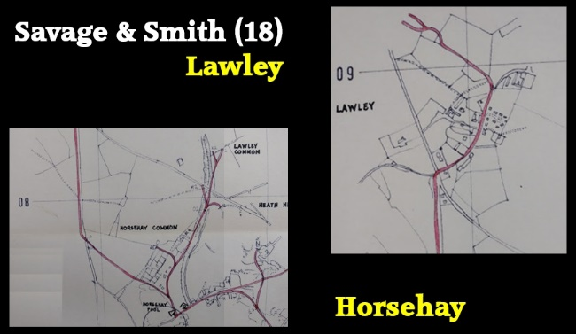
Slide 49 – this slide has two extracts from Savage & Smith’s fold out map. The plan on the Bottom left shows the area immediately North of Horsehay Ironworks which includes Horsehay Common, Lawley Common and Lawley Village. As can be seen, the tramroad serving Lawley Common follows the later GWR standard-gauge line quite closely to the East of Horsehay Common and was lost with the building of the standard-gauge line.
The extract to the top-right, shows the area further to the North. I have walked all the lines covered by these two plans. [6: p158]

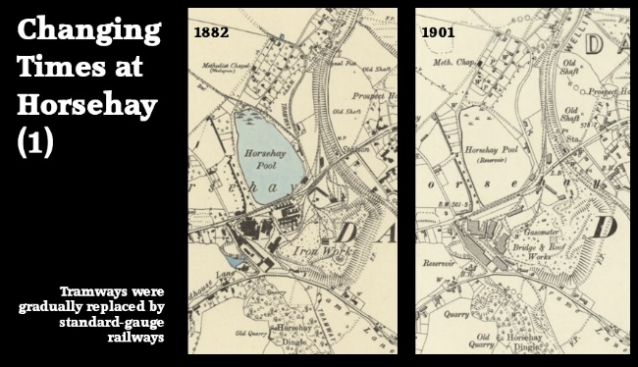
Slide 50 – This slide shows two Ordnance Survey Maps of the Horsehay area. At the time of the 1882 Ordnance Survey (published in 1885), the line to Lawley is shown as still in use to the full extent shown by Savage and Smith. That to Lawley Common is truncated a little further to the North. By the time of the 1901 revision (published in 1903) all of the tramroad lines North of Horsehay were no longer active.
Horsehay Works The first OS Plan shows the immediate area around Horsehay Ironworks as surveyed for the 1882 mapping and for which Savage and Smith do not provide a drawing. In the immediate vicinity of the Ironworks the track layout my well have been relatively fluid, particularly in the area of the spoil heaps to the Southeast of the Works, being changed from time to time depending on the work being undertaken.
The standard-gauge line is present on this Survey and a short branch serving the Horsehay ironworks is evident. This had transfer facilities next to Horsehay Pool. The Works were still served by a tramroad network. That network can be seen running Northeast across the standard-gauge line and South towards a Quarry to the Southeast of Horsehay Dingle.
The second OS Plan shows the changes to the same area over the 20 or so years following the 1882 survey. As can be seen on the map, the standard-gauge sidings have started to encroach into the works. Some tramroad tracks remain within the Works but they have been removed to the North and East and only extend South to the North end of Horsehay Dingle.
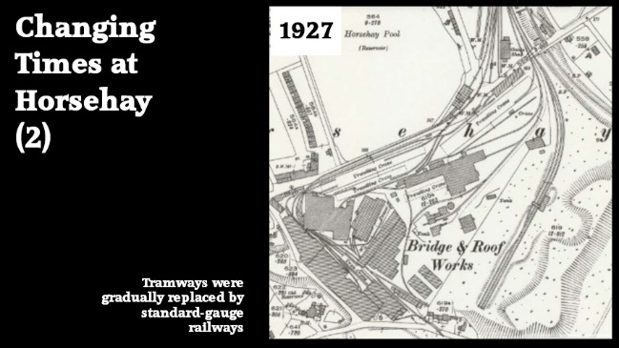
Slide 51 – shows how the works appeared in 1927. Significant areas within the works were by that date served by standard gauge railways.
A little more about this area can be gleaned from two further articles on my blog:
http://rogerfarnworth.com/2022/07/07/the-railways-of-telford-the-wellington-to-severn-junction-railway-wsjr-part-1-wellington-to-horsehay; and
http://rogerfarnworth.com/2022/07/12/the-railways-of-telford-the-wellington-to-severn-junction-railway-wsjr-part-2-horsehay-to-lightmoor-junction
These articles focus on the standard-gauge GWR railway but include material relevant to these maps towards the end of the first and then at the beginning of the second article.
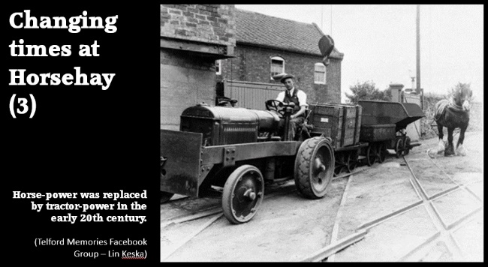
Slide 52 – This image comes from the early-middle of the 20th century. By this time Horse-power had been replaced by tractor-power on the remaining tramroads at Horsehay.

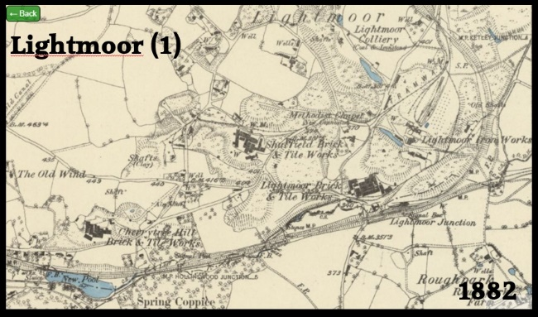
Slide 53 – Lightmoor Brick and Tile Works and Lightmoor Ironworks: the immediate area around these two different Works included a series of other industrial sites. The 1882 6” Ordnance Survey shows a strikingly busy area served by a couple of tramroads running approximately East-West and with the standard-gauge lines in place. Lightmoor Junction Station is shown with some limited facilities. A goods shed is shown to the North of the line with a single line extending from the tramroad to its North to the Goods Shed. [45]
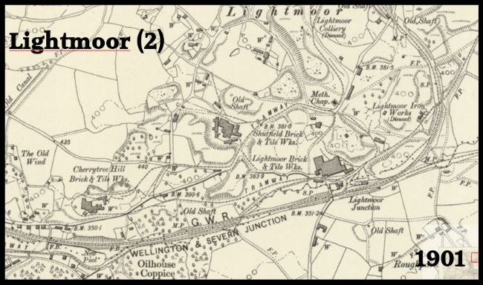
Slide 54 – This second Ordnance Survey plan shows virtually the same area. The coming of the standard-gauge network to this area seems to have resulted in significant developments in the local tramroad network. The newer lines connected industrial sites to the transfer facilities at Lightmoor Junction. These sites included Cherrytree Hill Brick & Tileworks, Shutfield Brick & Tileworks and Lightmoor Brick & Tile Works. By 1901, both Lightmoor Iron Works and Lightmoor Colliery had closed. The basic transshipment facility at Lightmoor Junction remained. [46]
Note the site of an old Inclined Plane, for which ‘The Old Wind’ was the engine house (on the left of the map extracts) and the Old Canal which it served. The Canal ran Northwest for a short distance before swinging East on the South side of Dawley Magna (North of Dawley Parva and close to Dawley Castle) to join the Shropshire Canal, Coalport Branch.
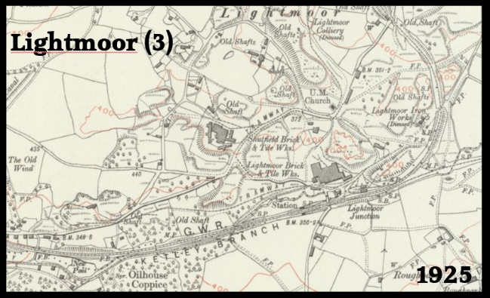
Slide 55 – This third OS Map focusing on the Lightmoor Area, shows that at the time of the 1925 Survey (which was published in 1928), parts of the network still were in use. Cherrytree Hill Brick & Tile Works were no longer in use, and the site seems, predominantly, to have been cleared. Shutfield Brick & Tileworks and Lightmoor Brick & Tile Works were still active and using the associated lengths of tramroad. [47]
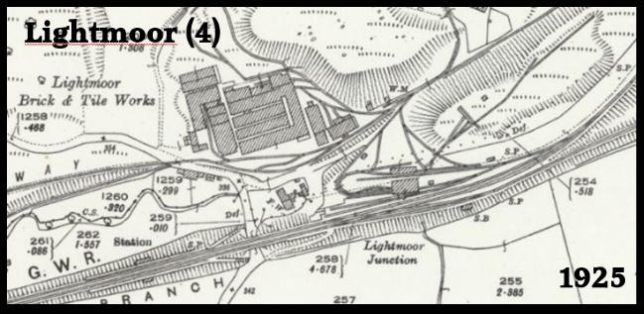
Slide 56 – This enlarged extract from the 1925 map shows the passenger station at Lightmoor Junction with enhanced transshipment facilities to its East. The tramroad is still in place on the route to Coalbrookdale which passes under a bridge and runs parallel to the standard gauge line on its South side. The tramroad route to the North of the line was the one which served the Cherrytree Hill Works. It is truncated a little to West of the area of the map extract. [47]
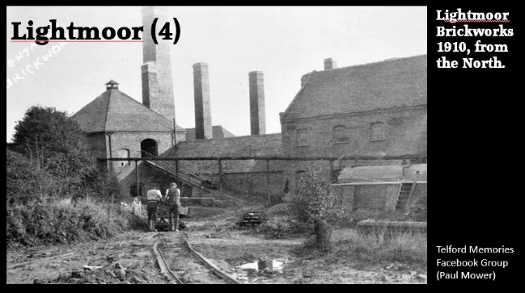
Slide 57 – This photograph was taken around 1910. Comparison of the building elevation with the 25” Ordnance Survey Plan published in 1927 suggests that the photographer was standing on the northern side of the main buildings, somewhere around the midpoint of those buildings but perhaps 25 to 30 metres to the North. The picture was shared on the Telford Memories Facebook Group by Paul Mower on 2nd April 2018. [48]
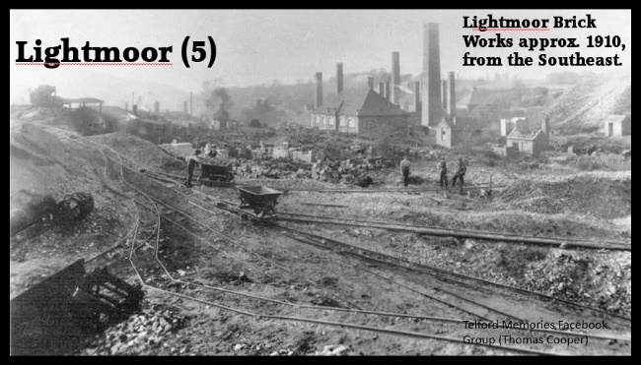
Slide 58 – This photograph was again taken around 1910. It gives a much broader view of the site. It is difficult to be sure where the vantage point is. The arrangement of the chimneys and the roof profile of the nearest building would suggest a point on the opposite side of the site from the first picture, possibly on the North side of the transshipment facilities. The photograph was shared by Thomas Cooper on 17th March 2017 on the Telford Memories Facebook Group. [49]

To summarize ….Tramroad construction and use in East Shropshire peaked between around 1820 and around 1860.
At first, most tramroads in the area were either local operating between two industrial sites or were used to take materials from various undertakings to the River Severn for onward shipment by Severn Trows.
Later, with the development of the local canal system, some tramroads became feeder lines for the canals, canal wharves allowed transshipment to tub-boats which then, generally, took materials to the River Severn for onward shipment.

Later, the arrival of the mainline railways and associated sidings meant that many tramroads carried goods to the railways for onward delivery. In some cases, routes remained the same but as time went by the longer tramroads disappeared.
Slide 59 – If you are interested in following up anything from this talk then a good place to start would be the detailed notes associated with it which can be found on my blog.
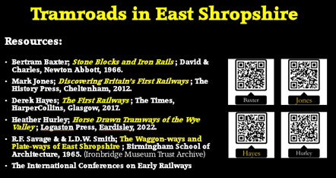
Slide 60 - And the books mentioned at the start of this talk.

References and Notes
- Peter King; Before the Main Line; in ed. David St. John Thomas; How Railways Changed Britain; Railway & Canal Historical Society, Derby, 2015, p13 – 32.
- https://www.sinfin.net/railways/railhist.html, accessed on 17th April 2022.
- https://www.csrf.ac.uk/blog/electrification-infrastructure, accessed on 17th April 2022.
- Bertram Baxter; Stone Blocks and Iron Rails (Tramroads); David & Charles, Newton Abbot, Devon, 1966.
- David Gwyn and Neil Cossons; Early Railways in England: Review and summary of recent research; Historic England, Discovery, Innovation and Science in the Historic Environment Research Report Series No. 25-2017.
- R.F. Savage & L.D.W. Smith; The Waggon-ways and Plate-ways of East Shropshire, Birmingham School of Architecture, 1965. An original document is held by the Archive Office of the Ironbridge Gorge Museum Trust.
- https://telford.org.uk/tramways/benthall_rwy.html, accessed on 22nd April 2022.
- https://telford.org.uk/tramways/caughley_rwy.html, accessed on 22nd April 2022.
- https://telford.org.uk/tramways/gleedon_hill.html, accessed on 22nd April 2022.
- https://telford.org.uk/tramways/sutton_wharf.html, accessed on 22nd April 2022.
- https://telford.org.uk/tramways/tarbatch.html, accessed on 22nd April 2022.
- https://rchs.org.uk/research-general-guidance, accessed on 19th April 2022 – particular reference is made to a document which gives a good sense of the development of various waggonways, tramways, plateways and Tramroads … Research-agenda.pdf which can be downloaded from the members area of the site. A link is provided below at Reference 35.
- Catherine Clark & Judith Alfrey; Research Paper No. 15, Benthall and Broseley Wood; Nuffield Survey, Third lnterim Report; University of Birmingham, 1987.
- https://maps.nls.uk/view/101594308, accessed on 9th January 2023.
- https://maps.nls.uk/geo/explore/#zoom=15.0&lat=52.68905&lon=-2.43995&layers=6&b=1, accessed on 9th January 2023.
- https://www.streetmap.co.uk/map?x=369643&y=311062&z=0&sv=369643,311062&st=4&tl=Oakengates+in+Telford+and+Wrekin&mapp=map&searchp=ids, accessed on 8th January 2023.
- J. Rocque; Map of the County of Salop (NE), 1752, examined at Shropshire Archives.
- R. Baugh; Map of the County of Salop (No. 5), 1808, examined at Shropshire Archives, Shrewsbury.
- Christopher Greenwood; Map of the County of Salop Facsimile Edition; Shropshire Archaeological and Historical Society, 2008.
- Ordnance Survey; Map 61(NE), 1833.
- https://www.timetoast.com/timelines/railroads-a167585d-a6ef-4bea-9b81-a141344ce16d, accessed on 9th January 2023.
- Chris Down; The Maltese cart ruts as railways: an experimental reconsideration; in Early Railways 4.*
- Warren Allison et al; An early railway in the German mines of Caldbeck; Early Railways 4.* (see also: J.F. Willock; Early Wooden Railways; Warwickshire Industrial Archeological Society, 2021; https://www.warwickshireias.org/early-wooden-railways, accessed on 9th January 2023.)
- Derek Hayes; The First Railway: Atlas of Early Railways; Times Books, HarperCollins, Glasgow, 2017.
- G. Smith-Groggen; Rutways in Cornwall; in Early Railways 4.*
- A. Skempton (ed.); Biographical Dictionary of Civil Engineers; ICE, London, 2002.
- M.J.T. Lewis; Early Wooden Railways; Routledge and Kegan Paul, London 1970.
- https://www.broseley.org.uk/Newsletters/BLHS%20Aug2017_Newsletter.pdf, accessed on 9th January 2023.
- https://www.heritagegateway.org.uk/Gateway/Results_Single.aspx?uid=3f055353-3a84-4575-9cf4-945464d26ba7&resourceID=19191, accessed on 15th April 2022.
- John Wooldridge; In the Footsteps of Bertram Baxter; Benthall Railway, Shropshire, 2007; http://www.telford.org.uk/tramways/benthall_rwy.html, accessed on 10th January 2023.
- John Wooldridge; In the Footsteps of Bertram Baxter: Tarbatch Dingle Tramroad, Shropshire, 2007; http://www.telford.org.uk/tramways/tarbatch.html; accessed on 10th January 2023.
- Extract from Benthall, A History of the County of Shropshire, Volume 10: Munslow Hundred (part), The Liberty and Borough of Wenlock; Victoria County History, London, 1998, p247-257; found on www.british-history.ac.uk
- Bob Yate; The Railways and Locomotives of the Lilleshall Company; Irwell Press, Clophill, Bedfordshire, 2008.
- C. von Oeynhausen and H. von Dechen; Railways in England 1826 and 1827; translated by E.A. Forward, ed. Charles E. Lee, Newcomen Society, 1971. Please see further notes below for detailed extracts.
- Helen Gomersall and Andy Guy; A Research Agenda for the Early British Railway; in Early Railways 4,* and accessed via. https://www.rchs.org.uk/wp-content/uploads/2016/11/Research-agenda.pdf, accessed on 1st January 2023. See some further notes below. [40]
- https://en.wikipedia.org/wiki/History_of_rail_transport, accessed on 11th January 2023.
- R.F. Tylecote; A History of Metallurgy, Second Edition; Maney Publishing, for the Institute of Materials, London 1992.
- A. Vaughan; Railwaymen, Politics and Money; John Murray, London, 1997.
- Surrey Iron Railway 200th Birthday Tour, 26th July 2003; Early Railways. Stephenson Locomotive Society; accessed on 12th January 2023.
- The parallel development of the two different rails and the choices which had to be made between the two were more convoluted than this paragraph suggests. Helen Gomersall and Andy Guy [35] comment as follows:
“Any discussion of iron rail development must be underpinned by an understanding of the fundamental alternatives which were available to those converting to or building with iron rails. The first choice was the decision whether to use plate- or edge-rail. In the choice of plate versus edge there are often clear regional preferences. Most notable was a strong inclination toward the use of plateways in south Wales, where a very large number were built from the beginning of the 19th century. Conversely, the waggonways of north-east England saw an almost total conversion from wooden to iron edge-rails. There has been little analysis of the factors which may have contributed to this preference, for example comparison of construction and running costs between the two systems. Local practice and convention, the use of existing waggon stock and the background of individual engineers and owners may all be significant.” [35]
“The use of plate-rail underground was popular even in areas which used edge-rail overground. Research is required, for example, to establish whether deep mines, which required transshipment at the shaft, tended to use surface edge-rail whereas areas of drift mines and open quarries used plateways throughout because transshipment was not necessary. Plate-rail offered the further opportunity to transfer road waggons directly onto a plateway and vice versa, an option that seems seldom to have been adopted … The importance of this and other factors to the divergence of the two systems over- and underground requires [further] consideration.” [35]
“There is … [a] need for analysis of the mechanism by which the knowledge and practice of the plateway was disseminated. Although the plateway was essentially a new system, the reasons behind the decision for its adoption have seen little discussion.” [35]
“The choice could have significant repercussions. The ‘L’ shape of the plate-rail allowed an accumulation of dirt and debris on the rail surface that led to increased friction. This effect was generally undesirable, but became especially problematic with the introduction of already underpowered locomotives. Plateway was also regarded as lacking the strength to bear the weight of locomotive engines which were considerably heavier than the laden waggons which had previously been run on lines of this type. [However,] these perceptions require testing. While there is no doubt that locomotive development would occur principally on edge-rail systems, it has yet to be clearly established if this was a necessity, or an accident of history.” [35]
“The second fundamental choice faced by those converting to or building with iron rails was that between cast iron and wrought (or malleable) iron. The choice was particularly crucial in relation to the use of edge-rails. The early forms were of cast iron: short, weak in tension and apparently prone to edge chipping. At the beginning of the 19th century, longer malleable- (or wrought-) iron rails promised a solution, with properties of greater strength in tension and an element of ‘spring’ to reduce shocks. However, initially there were production problems and objections that such rails laminated in use. The debate between those favouring cast or wrought was at times intense and deserves study, especially with regard to an engineering and materials assessment of the argument.” [35]
“New rolling techniques, credited to the Bedlington ironworks, were key to the successful production of wrought iron rails. These both yielded the required profile and allowed the formation of long rail lengths; essentially similar rails remain the industry standard today. It would be useful to consider what, if any, impact the impetus for new production methods and contemporary observations on the properties of cast and wrought iron had on the iron industry in general.” [35]
“Wooden, plate and iron edge-rails require in addition a comparative analysis of their overall engineering and financial performance. Key issues for study include whether the choice of rail type or material limited engineering decisions such as the maximum allowable gradient of the line or the minimum possible radii of curves. … Technical analysis is also required of the different strengths of plate and edge-rails, and of the working performance of each in terms of friction.” [35]
- N.W. Jones; A Wooden Waggon-way at Bedlam Furnace, Ironbridge; in Shorter Contributions and Notes; Post-Medieval Archaeology, Volume 21, 1987, p 259-262 (A copy of this short article is held in the Archives of the Ironbridge Gorge Museum Trust – Acc. No. 1989.3253, Class No. 656.4 9424.5.
- https://www.facebook.com/photo/?fbid=119428015717542&set=pcb.2476630165688305, accessed on 8th July 2022.
- https://maps.nls.uk/view/101594458, accessed on 19th January 2023.
- https://maps.nls.uk/view/101594455, accessed on 19th January 2023.
- https://maps.nls.uk/view/101594482, accessed on 19th January 2023.
- https://maps.nls.uk/view/101594479, accessed on 19th January 2023.
- https://maps.nls.uk/view/101594476, accessed on 19th January 2023.
- https://www.facebook.com/photo/?fbid=1001865753312225&set=pcb.2086719181346074, accessed on 13th July 2022.
- https://www.facebook.com/photo?fbid=271605153296996&set=gm.1584784474872883, accessed on 13th July 2022.
- https://www.facebook.com/visitingironbridge/photos/pcb.1322248871270351/1322248721270366, accessed on 21st January 2023.
- Mark Jones; Discovering Britain’s First Railways – A Guide to Horse-drawn Tramroads and Waggonways; The History Press, Cheltenham, Gloucestershire, 2012.
Additional Detailed Notes:
- Early Railways – in references [22][23][25][35] above, marked ‘*’ “Early Railways” refers to a series of conferences, the proceedings of which have been published over the years by The Newcomen Society. The books concerned are now collectors’ items. The contents of the first four volumes are provided below:
Early Railways – Volume 1
Sir Neil Cossons Keynote address
Dr M J T Lewis; Railways in the Greek and Roman world
Lars Olov Karlsson; A rediscovered early rail wagon
Dr John van Laun; Pre-1840 trackways in South Wales
Dr David Gwyn; Transitional technology: the Nantlle Railway
Rev Dr R L Hills; The railways of James Watt
Prof Roland Paxton; An engineering assessment of the Kilmarnock & Troon railway (1807-46)
Mike Wilmott; Early railways in Dorset: the industrial railways of Purbeck
Andy Guy; North eastern locomotive pioneers 1805 to 1827: a reassessment
Jim Rees; The strange story of the Steam Elephant
Colin E Mountford; Rope haulage: the forgotten element of railway history
Grahame Boyes; An alternative railway technology: early monorail systems
Richard Gibbon; Rings, springs and things: the national collection pre 1840
Mike Clarke; The first steam locomotives on the European mainland
Ian Cowburn; The origins of the St Etienne rail roads, 1816-38: French industrial espionage and British technology transfer
Prof Frederick C. Gamst; The transfer of pioneering British railroad technology to North America
Herb MacDonald; The Albion mines railway of 1839-40: some British roots of Canada’s first industrial railway
Dr Michael R Bailey & John P Glithero; Learning through restoration: the Samson locomotive project
Dr John Banham; Coal, banks and railways
Dr Winifred Stokes; Early railways and regional identity
J H Baldwin; The Stanhope and Tyne Railway: a study in business failure
Dieter W Hopkin; Reflections on the iconography of early railways
Early Railways – Volume 2
Prof Colin Divall; Keynote address: Beyond the history of early railways
Dr Barrie Trinder; Recent research on early Shropshire railways
Robert Stephenson Roper; Robert Stephenson, senior, 1788-1837
Dr David Gwyn; Artists, Chartists, railways and riots
David Hodgkin;s; Success and failure in making the transition to a modern railway: the Liverpool & Manchester and Cromford & High Peak
Andy Guy; Early railways: some curiosities and conundrums
Dr Winifred Stokes; Who ran the early railways? The case of the Clarence
Dr John van Laun; In search of the first all-iron edge-rail
Dr M J T Lewis; Bar to fish-belly: the evolution of the cast-iron edge-rail
Colin E Mountford; Researching rope-haulage ― a case stud: the Lambton Railway, 1800-1835
Sheila Bye; John Blenkinsop
John Crompton; The Hedley mysteries
Paul Reynolds; George Stephenson’s 1819 Llansamlet locomotive
Jim Rees; The Stephenson standard locomotive (1814-1825): a fresh appraisal
John Liffen; The Patent Office Museum and the beginnings of railway locomotive preservation
Rev Dr Richard L Hills; Richard Roberts’ experiments on the friction of railway waggons
Richard Gibbon & Richard Lamb; ‘Running wi’ your breeks down’: an investigation of coupling rod resistance in a four-coupled locomotive
Dr Stefano Maggi; An early railway in Tuscany: Follonica–Montembamboli
Herb Macdonald; Reconsidering the origins of Canada’s first locomotive-powered railway: the Champlain & St Lawrence, 1825-34
Early Railways – Volume 3
Andrew Scott; Keynote address: ‘First’ impressions ― some reflections on 2004, early railway’s year of anniversaries
Dr M J T Lewis; Reflections on 1604
Dr John van Laun; New light on the wooden waggonways at Whitehaven harbour
John Goodchild; The Lake Lock Rail Road
John Liffen; The iconography of the Wylam waggonway
Colin E Mountford; The Hetton Railway ― Stephenson’s original design and its evolution
Herb MacDonald; The Cape Breton waggonways of the General Mining Association, 1830-1855
Anthony Coulls; The Corris, Machynlleth & River Dovey tramroad
Alan M Levitt; How America discovered the railway
William L Withuhn; Abandoning the Stourbridge Lion ― business decision-making, 1829: a new interpretation
Winifred Stokes; The importance of the northeast viewers in the development of early railways and locomotives
Niall Ferguson; Anglo-Scottish transfer of railway technology in the 1830s
Jim Rees & Andy Guy Richard; Trevithick and pioneer locomotives
Roger Darsley; Some considerations on the origins of the chaldron waggon in the northeast of England
Rev Dr Richard L Hills; The development of machine tools in the early railway era
Helen Gomersall; The Round Foundry of Leeds
Dr Michael R Bailey; Restaging the Rainhill Trials, learning from replicas
Richard Lamb; Something of a Novelty
Peter Davidson & Dr John Glithero; Analysis of locomotive performance

Early Railway – Volume 4
John Liffen; Trevithick Bicentenary Address: Searching for Trevithick’s London railway of 1808.
Dr Chris Down; The Maltese cart ruts as railways: an experimental reconsideration.
Geoff Smith-Grogan; Rutways in Cornwall.
Warren Allison, Samuel Murphy & Richard Smith; An early railway in the German mines of Caldbeck.
Dr Peter King; The first Shropshire railways.
Neil Clarke; John Wilkinson’s railway at Willey.
Michael Messenger; Early railways in the South-West.
Stephen Hughes; The emergence of the public railway in Wales.
Dr David Gwyn; ‘What passes and endures’: the early railway in Wales.
Sheila Bye; Regarding old rails: a Middleton Railway miscellany.
Robert Hartley; The Coleorton Railway.
Miles Macnair; The Central Junction Railway of 1820: a study in historical perspective.
Dr Michael Lewis; Constructional and temporary railways.
Dr Winifred Stokes; A City job: the London shareholders in the Clarence Railway.
Herb MacDonald; The Rideau waggonway that never was: rail vs canal in the defence of Canada, 1814-25.
Roger Darsley; The Durban Bluff Railway and the early railway scene in South Africa.
Jim Rees; The Sans Pareil model: a pivotal moment.
Dr Michael Bailey & Dr John Glithero; Turning a blind eye to Braddyl.l
Dieter Hopkin; Timothy Hackworth and the Soho Works, circa 1830-50.
Andy Guy; Just add boiling water: the elusive railway kettle, 1804-25.
Dr Niall Ferguson; Locomotives of the Dundee & Arbroath Railway: timely new evidence?
Colin E Mountford; The Bank Top engine, Burnhope, Co Durham.
Helen Gomersall & Andy Guy; A research agenda for the early British railway.

- C. von Oeynhausen and H. von Dechen; Railways in England 1826 and 1827; translated by E.A. Forward, ed. Charles E. Lee, Newcomen Society, 1971 …. Authors (pIX-X)

“When the authors of this report came to England in 1826, they had both secured recognition in Prussia as mineralogists and geologists, and were civil servants with the rank of Supervisory Assessor in the Mining Department of the Ministry of the Interior. At the time of their visit von Oeynhausen was 31 years old and von Dechen 26. When the report was prepared, the name 'Carl' was spelled. normally with a 'C' and this initial appears on the title-page. This practice has survived in English with such names as Cologne, but, as a result of the increasing substitution of 'K' in German usage, the references to the authors in standard German biographies use 'K'.

Karl August Ludwig Freiherr von Oeynhausen was born at Grevenburg, near Höxter, in Westphalia, on 4 February 1795. He chose mining as his profession, and began his practical training in the mines of Cisleben. Then he entered the University of Göttingen, where he studied Natural Sciences and Mathematics until 1816, but with a break of some months in 1813 and 1814, when he served the Fatherland in resisting the invasion of Napoleon. In 1816 he joined the Mining Office at Waldenburg, in Silesia, and in 1817 went to Tarnowitz, in Upper Silesia. At the latter place he achieved some distinction for his geological investigations of Upper Silesia and the neighbouring territory, on which subject he published a book in 1822. After he had passed the qualifying examination for mining on 1 April 1820, he was attached to the Westphalian Mining Office, and in 1824 he was appointed Chief Mining Official in the Mining Department of the Ministry of the Interior. He travelled extensively through Germany, Northern France, the territory which became Belgium, and Great Britain, enlarging his knowledge of mining practice. After returning from Great Britain in 1827, he was appointed Technical Officer in the Head Mining Office in Berlin, and thereafter pursued a distinguished career in various parts of the country. He was at Bonn in 1828, and at Dortmund later in the same year, where he was appointed Chief Mining Councillor. As such, he went in 1830 to Halle and in 1831 to Bonn, where he remained for ten years. In 1844 he was appointed a Privy Councillor in the Finance Ministry, to which the mining works and salt works were attached. His name is associated particularly with the boring for salt at Neusalzwerk, where numerous improvements in boring tackle are attributed to him. He was instrumental in establishing the salt baths at Neusalzwerk, opened on 18 May 1845, and Friedrich Wilhelm IV recognised his work on 25 August 1845 by giving this spa the name 'Bad Oeynhausen'. In 1860 the University of Berlin conferred on von Oeynhausen a Doctorate (honoris causa). Ill health caused his resignation from the mining service in June 1864, and his return to his family at Gravenburg, where he died on 1 February 1865, only three days short of his seventieth birthday.

Ernst Heinrich Karl von Dechen was born in Berlin on 25 March 1800, and was educated in the University of that city. He then studied mining in Bochum and Essen, and in 1820 joined the Mining Department of the Prussian State, in which he served until 1864. Early in his carcer, he spent some years in travels through the important mining districts of Germany, England, and France. For his work as a university lecturer, he received the degree of Doktor (honoris causa). In 1841 he transferred to Bonn as Superintendent of the Mines of the Rhine Provinces, and substantial progress in mining and metallurgical works in Rhenish Prussia resulted from his activities. In the winter of 1859-60 he took over temporarily the direction of the Department of Mines, Factories, and Salt Works in the Ministry of Commerce. He retired from the State Service in 1864 with the title of Excellency, but he then had before him another quarter of a century of activity in civil government. In Bonn, he had become a Town Councillor in 1846, and he continued in office until the end of his life. Also, he was called to the Prussian Council of State in 1884. It has been stated of von Dechen that there was scarcely any large industrial undertaking in the Rhineland or Westphalia that was not indebted to him. He made considerable efforts towards improving the means of transport in mining, and also in the related activity of extending the markets for the products of mines and factories. His scientific work was basically in the sphere of geology, and his numerous contributions to geological literature extend over the period from 1825 to 1882. An outstanding work was his geological map of Rhenish Prussia and Westphalia in 35 sheets on the scale of 1:80,000, issued with two volumes of explanatory text. He died at Bonn on 15 February 1889.

Brief biographies of both authors are given in Biographisch-Literarisches Handwörterbuch by J. C. Poggendorff; and by Dr Conrad Matschoss (1871-1942), the German engineering historian, in Männer der Technik. The Encyclopaedia Britannica (11th edition, 1910) includes a note on von Dechen by Horace Bolingbroke Woodward of the Geological Survey of England and Wales. There are also the separate volumes Karl von Oeynhausen by O. Liesenhoff, Berlin, 1895; and Heinrich von Dechen, ein Lebensbild by Hugo Laspeyres, Bonn, 1889.

- C. von Oeynhausen and H. von Dechen; Railways in England 1826 and 1827; translated by E.A. Forward, ed. Charles E. Lee, Newcomen Society, 1971 …. Author’s Introduction (p1-2)

It would be difficult to find a subject which, in recent years, has attracted so much general interest as that provided by the extensive schemes which have been, and are still being, prepared daily in England, for the improvement of inland communications. When, on the one hand, newspaper accounts and other reports about railways on which general traffic of all kinds of vehicles takes place, or of locomotive engines which run on ordinary roads, and of the enormous speeds with which these move, the matter becomes almost ridiculous; on the other hand there is still lacking more definite and descriptive news about these schemes. Hitherto, railways have been designed for different purposes, but chiefly to bring coal, ore, slag, and stone from the source to the destined place of use. At some places they are employed for connecting separate parts of canals, especially where great differences of level, in short distances, would have made a water connection very difficult. Hitherto there have never been railways destined solely for this purpose, which were intended to be laid on ordinary roads, among all the various traffic found on them, and that which is now being laid between Liverpool and Manchester, should certainly fulfil this aim, but only under very special conditions. On another railway which is intended chiefly for the transport of coal, limestone, and the like, there is incidentally a regular coach service.

The first use of railways in England is supposed to have been made at the collieries of Newcastle, about 1630, in order to transport the coal from the pits to the staiths on the Tyne. At that time, they were built of wood, as they are at present at many mines in Germany. In the middle of the last century, when wood became dearer, and the use of cast-iron more general, these rails were made of cast-iron, and only in the past few years have wrought-iron rails been employed. Wherever a large weight of goods has to be transported regularly between two fixed points, then railways show themselves to be practicable; these circumstances occur especially at mines and then depots and at foundries. At first, they were used only over small stretches of country; hills to be passed over set a limit to their use. Soon, however, it was shown to be of special advantage to allow loads from the heights to descend; complete canal boats were let down and drawn up by means of inclined railways between the parts of canals. Similar inclined planes were placed to connect nearly level railways, and so the possibility of overcoming every difficulty of the ground was offered by them. For a long time, railways had only a restricted use. For connecting more widely separated points, special systems of canals were made in England after the first, the Sankey Canal, 1755, and the Bridgewater Canal, 1758, had so completely fulfilled their purpose. Once the costly outlay was made, canal transport was very cheap-so long as a water supply was available and also regular, excepting when winter frost is taken into consideration. At present there are about 80 canals in Great Britain. Many, however, are far from being able to pay the interest on their cost of construction, and with more than 40 the shares have only half their original value. There is a limit to the speed of the canal boats, which can be exceeded only with disproportionate expenditure of power. Besides this, the amount of the water supply sets a limit to the weight which can be transported; while the form of the country may necessitate long detours or make the laying out extraordinarily difficult. These circumstances have made it possible for railways to compete with canals, so that the scheme for a railway between Manchester and Liverpool, which already have a canal connection, is on the point of being accomplished. In general, railways are more suitable for comparison with canals (and to replace and to compensate for them), than roads. At least until now, roads have not been replaced by canals. The form of the land restricts the layout of roads very little; they are not obliged to conform to regular divisions of ascents, descents, and horizontal levels, and they permit the general use of any kind of vehicle. Also, the maintenance of roads and transport thereon are far more costly than is the case with railways.

For a long time, horses provided the only motive power employed on railways and canals; on the latter they are still used except on inclined planes, upon which steam engines and water wheels are employed as the motive power. Since the beginning of this century, steam locomotive engines have been constructed, and attempts have been made to replace horses on railways by these. However, even at the most favourable points, their applicability has not yet been sufficiently proved, and at present they are employed only under certain restricted conditions. The use of stationary steam- engines for inclines where the loads are upwards, and also on the level parts of the line, has become common, and they appear to be very suitable where considerable loads must be transported over a line, and where a high speed is required. We are strongly of the opinion that railways should take in civil engineering a far-reaching share which until now has been little cultivated. This is by reason of their objects; of the country they traverse; of the kind of layout; of the moving powers and their effects; of their cost of construction and maintenance, and of their whole economic aims.

Two of the most remarkable railways in the north of England, the so-called Darlington Railway from Bishop Auckland to Stockton on Tees, and the Hetton Railway from the Colliery of the same name to Sunderland on the Wear, must be cited as examples, the former of a wrought-iron, and the latter of a cast-iron railway. Inclined planes with stationary steam-engines; self-acting planes, where the full wagons descending draw up the empty ones; stationary steam-engines which effect the haulage on nearly horizontal stretches of line; locomotive engines; – all present themselves in this connection.

Then further remarks will be made about some other railways in England, Wales, and Scotland; about inclined planes which are connected with canals; and about special and distinctive methods of constructing railways and their applicability.

Finally, several matters will be discussed with regard to their plans and effects, the chief aim of
which will be to answer the question as to what conditions in the laying out of railways are practicable and suitable for the end in view.

So many and so varied are the circumstances concerned that a comprehensive general statement would be difficult to express, and in every case a special comparison of all concurrent conditions is necessary. Meanwhile, it is always possible to explain this by statements of experience and surveys. A private individual, when he makes such a plan, must take entirely different considerations into account from those which affect the State, when it considers it advisable to undertake such a work in order to attain higher or more extensive aims. The first must keep to a close estimate of the expected profits, or he must make certain of covering any loss by the predominant profits in other branches of his business; he must calculate the interest on the business capital at so high a rate that he can repay the capital by degrees therefrom. The State, on the other hand, must place this outlay in the category of that which repays itself by indirect advantages, through the enlivenment of industry, and of internal communications, through the increase of the national wealth, but not through direct revenue. When a private owner collects a toll for the use of a railway, this must amply cover all interest and running costs. However, when the State imposes such a toll, only the running costs, and those of maintenance, administration, etc., need be met by this income.

As matters now stand, it would seldom be the case that the State would take such a general interest in a railway as to give a considerable interest-free capital to the scheme. Such arrangements are more suited to raising the production of single works or establishments than to influence the common trade of whole districts. However, such cases can occur, if it is shown that railways provide a regular connection more effectively than canals, which need sufficient water, or than making navigable rivers with steep descents. The smaller cost of construction of the railway could assure a more moderate freight charge at all times than can be achieved upon the waterways.

- C. von Oeynhausen and H. von Dechen; Railways in England 1826 and 1827; translated by E.A. Forward, ed. Charles E. Lee, Newcomen Society, 1971. …. (p67)

From the River Wye, near Mitchell Dean, a tramroad through the Forest of Dean to Lydney on
the Severn, with a branch past Coleford to Monmouth; another tramroad 5 miles Engl. long leads
from the Severn to the collieries of the Forest of Dean.

At the many collieries and ironworks in Staffordshire, in the neighbourhood of Dudley, and in
the large limestone quarries of the district, only one kind of railway is employed—German cast-iron
rails, Tramroads—which also rest on cast-iron sleepers. The cast-iron sleepers are 2 in. thick, 3 to
4 in. wide, and at each end have a 9-in. long and wide extension upon which is a dovetail-shaped
notch, in which the rails can be fixed easily. At each end, outside the flange, the rails have a part
becoming wider at the bottom, which fits into the notch in the sleeper. The rails are often only
/ in. thick, and 21 in. wide; the flange is likewise / in. thick and is 1/ in. high. On curves, cast
curved rails are used. These are provided with a very strong flange from 1 in. to 1/ in. thick, because
it is affected more injuriously than on the straight parts of the line. Where the tramroad crosses
other public roads or highways, stronger rails provided with two flanges are used. They form a
narrow channel into which the wheels of passing road vehicles cannot slip. The upper surface of
these two edges is better made uneven, by small arc-shaped projections, than cast wholly smooth,
so that wheels travelling across the rail shall not slip to and fro. This kind of rail is used not only
here but wherever tramroads cross public roads.

Hereabouts, in Coalbrookdale, a cast-iron tramroad runs from the Severn to the lower iron smelting works of the Dale Company. As is the case with all tramroads in this district, it belongs to the same species. The rails are 5 and even 5½ft long and lie in cast-iron sleepers. The tramroads at Coalbrookdale are of two sizes. The smaller one is of 20 in. gauge, and the haulage on this is performed with small trucks; it lies in the middle of a larger line of 36 in. gauge. Horse haulage is used thereon. It, perhaps, merits remark that the smallest gauge for horse use employed anywhere is to be found in this district, as on some lines the gauge is only 18 in.

At the Horsehay Ironworks, which also belongs to the Dale Company, there are tipping wagons with sheet-iron bodies on wooden frames, very suitable for the transport of blast-furnace slag. The wheels on these wagons are from 14 to 18 in. diameter, and have wider wheel rims than are employed elsewhere in England, and especially in South Wales, namely 1 to 1½ in.

All these rails are so laid that the flange lies on the inner side, and at the same time holds together the hauling path. (p67)

- C. von Oeynhausen and H. von Dechen; Railways in England 1826 and 1827; translated by E.A. Forward, ed. Charles E. Lee, Newcomen Society, 1971. … XX. Self-acting Plane from the Shropshire Canal to the Severn near Coalbrookdale (p73-74)

About 2 miles below Coalbrookdale, the Shropshire Canal is united with the Severn by a self-acting plane 793ft long (the authors point out later that Thomas Tredgold gives this length as 1,050 ft in his book, "A Practical Treatie on Rail Roads and Carriages', which was first published in 1825 – please see the end of this section) and with a vertical drop of 207ft, or an angle of [15.125] degrees. The railway thereon is of cast-iron, built in the manner of a tramroad. The rails are the strongest and thickest of the kind that we have seen; also, they lie on longitudinal timbers 14 in. wide and thick, and these upon wooden cross-sleepers. The whole inclined plane is well paved. The tramroad has three lines of rails, so that it forms two tracks with one common rail; in the middle of the plane, where the full and empty wagons pass one another, there are four lines of rails forming two separate tracks. On one track, the rail flanges are inside, and on the other track outside. The rails are 70 in. (6ft Engl.) long: 7 in. wide, exclusive of the 2½, in. high and 1 in. thick flange; and 2 in. thick. On one end there is projecting point 5 in. broad and 1 in. long and on the other end a suitable notch in which the point fits. In addition, there is a tab on the flange through which a wooden plug is inserted to connect the two rails; four 1-in. square holes enable the rails to be spiked to the longitudinal timbers.

The connection of the rails by wooden plugs is seldom used, and only a few rails are provided with the small recess in the middle of the flange. In the track are iron rollers over which the rope runs.

The canal boats which arrive on the Shropshire Canal are let down on this self-acting plane. A wooden wagon frame is used for lowering them. Most of the canal boats are of wood, 18 ft long, 5ft 2 in. wide, and 24 ft deep, in the clear. One such boat weighs about 11 tons empty, and the greatest load amounts to about 5 tons, whereby it still has about 3 in. freeboard. The cargo consists of coal and iron.

The wooden frame on which the boats are placed is of very simple construction. On the two outer frame beams stand posts 5 ft high, fixed by struts, and connected at the top by an iron cramp provided with three eyes for the attachment of the chain. The frame has two large front wheels 27 in. diameter, and two small hind wheels 16 in. diameter, which have an inside gauge of 43 in. They are 6 in. wide at the rim, and 10 in. long in the nave; these lie wholly under the frame. Outside of the wagon there are also two outer flanged wheels of 24 in. diameter on the same axle as the small hind wheels, and with a gauge of 78 in. When the wagon is drawn out of the canal upon the bank of the self-acting plane, these wheels run upon a special railway, and thereby enable it to pass over the highest point of the bank without rubbing. The weight of the wagon frame is 2 tons and the boat with its load, 6½ tons, therefore the total weight is 8½ tons or 170 cwt. About 100 boats can be let down in 12 hours.

A 16-in. steam-engine stands on the highest point of the self-acting plane, on the ridge formed by it and by the short inclined plane leading to the canal. This serves to draw the wagon with the canal boat out of the upper part of the canal. It also completes the drawing up of the wagon coming up the self-acting plane, when the full wagon, with the boat, has plunged into the water, and thus so reduced its effective weight that it is no longer able to draw the empty wagon right to the top of the plane.

On the axle of the steam-engine there is a small gear-wheel with 24 teeth, which engages with a larger wheel with 96 teeth, on the axle of which is fitted the rope drum of 7 ft diameter, with the brake wheels for the self-acting plane. The small gear-wheel can be put in or out of gear by a contrivance operated in the engine house, so that the engine and the rope drum can move independently of one another. The rope goes from this drum over iron rope-sheaves 6 ft diameter and 5 in. wide, and then under the drum away to the self-acting plane; the rope-sheaves hang perpendicularly over the upper part of the canal, so that the wagon can be drawn forward over the ridge.

A pinion with 40 teeth on the axle of the steam engine engages with a wheel with 96 teeth mounted on an intermediate axle which also carries a pinion with 28 teeth. This intermediate axle has bearing-seat inside the engine house, and can be put in or out of gear by means of a lever, so that this axle can be put in motion or at rest according to choice. The pinion of 28 teeth engages with wheel of 80 teeth which is mounted on the axle of a small chain-drum and brake wheel; through this drum, and a chain, the canal boat is drawn out of the upper part of the canal on to the top of the self-acting plane. The manipulation of the brake is as follows:-As soon as the full wagon comes to the bottom, the laden boat is removed by a workman and pushed into the canal, and, in exchange, an empty boat is brought on and affixed. The full down-going boat does not draw up the empty one the whole distance, because the tramroad goes entirely under the surface in the lower canal, and the loaded boat, as soon as it plunges into the water, loses much of its weight. As soon as the empty boat stops, a workman releases the brake on the large rope drum, while another puts the engine in connection with this drum and sets it in motion so that the boat shall continue its journey upwards and across the ridge of the self-acting plane. When the boat has reached the ridge, it goes slowly on the tramroad into the upper canal. The large rope-drum is then disconnected from the engine, the engine stopped, and two workmen push the empty boat off the wagon, put on a full one instead, and attach the wagon to the chain of the small drum. This chain was unwound during the time that the empty boat was passing over the ridge, at which time also the chain-drum was connected with the engine. As soon as the full boat is pushed on, the engine is started, and, by means of the chain, draws the full boat upwards out of the canal on to the ridge of the self-acting plane. One workman stands at the engine, the other at the brake. As soon as the boat is across, it is attached to the rope of the large drum and let down the plane by means of the brake. To permit this, the engine is stopped, and the chain-drum disconnected from it; this done, the workman removes the chain from the wagon, and puts on the brake, keeping it on until the full boat plunges into the water at the lower canal. In between, a workman has time to attend to the firing of the engine, and to bring the boats into position and attach them, so that little time is lost. The workman at the lower canal is also employed in the unloading, etc., as affixing and detaching the boats requires little time. At Coalport on the lower canal a ton of coal costs 8s., … a very low price when the fact that already the coal has come from the pit many miles distant is taken into consideration.

All the connecting wheels of the brake-arrangements are cast in two parts, which reduces the danger of breakage when they are being staked on their axles. The axles are of cast-iron 4 in. square, the journals 34 in. diameter, the wheels 3 in. in the split part. The engine crank is 18 in. long. The rope which lets down the wagons is 3½ in. diameter.

The large rope-drum makes ¼ of a revolution for one revolution of the engine shaft, and the small chain-drum makes … about of [1/7th] of a revolution. Tredgold, in his book: A Practical Treatise on Rail Roads and Carriages gives the length of this incline as 1,050 ft. In addition, he states that the Shropshire Canal has two other self-acting planes; the second 1,800 ft long and with 126 ft fall, or an angle of somewhat over 4 degrees; the third 1,050 ft long and with 120 ft fall, or an angle of 7 degrees.

